|  |  |  |  |
| --- | --- | --- | --- |
|  | **VERY HIGH RESOLUTION REMOTE SENSING OF *PORTULACARIA AFRA* CANOPY COVER** | |  |
|  | By Dugal Harris | |  |
|  | *Thesis presented in partial fulfilment of the requirements for the degree of Master of Science at the Stellenbosch University.* | |  |
|  |  | |  |
|  | Supervisor:Prof A van Niekerk  December 2014 |  | |
|  |  | |  |

DECLARATION

By submitting this report electronically, I declare that the entirety of the work contained therein is my own, original work, that I am the sole author thereof (save to the extent explicitly otherwise stated), that reproduction and publication thereof by Stellenbosch University will not infringe any third party rights and that I have not previously in its entirety or in part submitted it for obtaining any qualification.

|  |  |
| --- | --- |
| Date: |  |

Copyright © 2013 Stellenbosch University

All rights reserved

SUMMARY

Summary

**KEY WORDS**

Keywords

OPSOMMING

Opsomming

**TREFWOORDE**

ACKNOWLEDGEMENTS

I sincerely thank:

* My supervisor Prof Adriaan van Niekerk for his valuable guidance and support.
* Jan Vlok for initially suggesting the topic, providing expert botanical knowledge of my study area and for his generous assistance with ground truthing in the field.
* The Gamtoos Irrigation Board and Andrew Knipe for funding the research.
* Julie Verhulp, Raoul Duesemi and the rest of the staff at National Geospatial Information for their help with sourcing imagery of the study area.
* Adrian Roos of Intergraph SA for providing an evaluation license for the Intergraph ZIPPS calibration software.
* Bernhard Jacobs of Geospace for useful discussions on image calibration and for providing the camera calibration data.
* Theo Pauw and Garth Stephenson of the Centre for Geographical Analysis for providing software support and server access.

CONTENTS

DECLARATION ii

SUMMARY iii

OPSOMMING iv

ACKNOWLEDGEMENTS v

CONTENTS vi

TABLES viii

FIGURES ix

APPENDICES x

ACRONYMS AND ABBREVIATIONS xi

CHAPTER 1: INTRODUCTION 1

1.1 SIGNIFICANCE AND RATIONALE 4

1.2 PROBLEM STATEMENT 7

1.3 RESEARCH AIM AND OBJECTIVES 7

1.4 STUDY AREA 7

1.5 METHODOLOGY 8

CHAPTER 2: Retrieval of Surface Reflectance From Aerial Imagery By CalibratiON with Satellite Data 11

2.1 ABSTRACT 11

2.2 INTRODUCTION 11

2.3 METHODS 14

2.3.1 FORMULATION 14

2.3.2 STUDY SITE, DATA COLLECTION AND PREPARATION 18

2.3.3 ACCURACY ASSESSMENT 20

2.4 RESULTS AND DISCUSSION 21

2.4.1 Band Averaged Relationships 21

2.4.2 Mosaicking 22

2.4.3 MODIS Comparison 25

2.4.4 SPOT 5 Comparison 27

2.5 CONCLUSIONS 31

CHAPTER 3: FEATURE CLUSTERING AND RANKING 33

3.1 ABSTRACT 33

3.2 INTRODUCTION 33

3.3 DATA AND GROUND TRUTH 36

3.4 FEATURES 37

3.5 METHOD 39

3.6 RESULTS AND DISCUSSION 40

3.6.1 Standard Feature Selection 40

3.6.2 Clustering and Ranking 41

3.7 CONCLUSIONS 44

CHAPTER 4: VERY HIGH RESOLUTION MAPPING OF *PORTULACARIA AFRA* CANOPY COVER 47

4.1 ABSTRACT 47

4.2 INTRODUCTION 47

4.3 STUDY AREA 49

4.4 DATA AND GROUND TRUTHING 50

4.5 METHODOLOGY 54

4.6 FEATURES 55

4.7 FEATURE SELECTION 58

4.8 CLASSIFICATION 59

4.9 RESULTS AND DISCUSSION 62

4.9.1 Feature Selection 62

4.9.2 Classification 65

4.10 CONCLUSIONS 72

REFERENCES 75

**PERSONAL_COMMUNICATIONS 6**

**APPENDICES 7**

TABLES

Table 2.1 Statistical comparison between MODIS and DMC surface reflectance images 27

Table 2.2 Statistical comparison between SPOT 5 and DMC surface reflectance images 31

Table 3.1 Class descriptions 36

Table 3.2 Ground truth size 37

Table 3.3 Features 37

Table 3.4 Experiment 1: Forward selection results for different data sets 40

Table 3.5 Experiment 2: Forward selection results for different selection criteria 41

Table 3.6 Experiment 3: Feature selection results for different search methods 41

Table 3.7 Ranked clusters 43

Table 3.8 Experiment 4: Feature clustering and ranking results for different data sets 43

Table 3.9 Experiment 5: Feature clustering and ranking results for different selection criteria 44

Table 3.10 Classifier performance comparison 44

Table 4.1 Field ground truth site information 52

Table 4.2 Class descriptions 52

Table 4.3 Image ground truth size 54

Table 4.4 Features 58

Table 4.5 Ranked clusters 65

Table 4.6 Classifier parameters 67

Table 4.7 Classifier performance comparison 67

Table 4.8 Decision tree three class confusion matrix 68

Table 4.9 Decision tree two class confusion matrix 69

Table 4.10 Decision Tree field canopy cover estimates 69

FIGURES

Figure 1.1 Intact and degraded subtropical thicket 1

Figure 1.2 CIR Image of *P. afra* Thicket 6

Figure 1.3 Location of the study are within the Little Karoo 8

Figure 1.4 Research design 10

Figure 2.1 Study area orientation map 19

Figure 2.2 SPOT scene and mosaic extents 21

Figure 2.3 DMC and MODIS RSR’s 22

Figure 2.4 DMC vs. MODIS band averaged relationship for typical surface reflectances 22

Figure 2.5 Camera calibrated mosaic on MODIS reference image background 23

Figure 2.6 Radiometrically calibrated mosaic on MODIS reference image background 24

Figure . Reduction of hot spot and seam lines. (a) Raw DN images showing hot spot and seam lines (b) Corrected surface reflectance image 25

Figure 2.8 DMC DN mosaic and MODIS surface reflectance correlation 26

Figure 2.9 DMC surface reflectance mosaic and MODIS surface reflectance correlation 26

Figure 2.10 DMC and SPOT surface reflectance comparison. (a) DMC surface reflectance mosaic masked to SPOT extent. (b) SPOT surface reflectance image. (c) Contrast stretched absolute difference image. 29

Figure 2.11 DMC and SPOT RSR’s 30

Figure 2.12 DMC DN mosaic and SPOT surface reflectance correlation 30

Figure 2.13 DMC surface reflectance mosaic and SPOT surface reflectance correlation 30

Figure 3.1 Clustering of correlated features 42

Figure 4.1 Little Karoo study area 50

Figure 4.2 Study area *P. afra* habitats and field ground truth sites 51

Figure 4.3 Matjiesvlei2 ground truth site 52

Figure 4.4 Hand labelled ground truth 54

Figure 4.5 Clustering of correlated features 63

Figure 4.6 Groenfontein classification (Habitat: valley thicket with Spekboom) 70

Figure 4.7 Matjiesvlei classification (Habitat: arid thicket with Spekboom) 71

Figure 4.8 Rooiberg classification (Habitat: arid thicket with Spekboom and Fynbos mosaic) 71

Figure 4.9 Grootkop classification (Habitat: arid thicket with Spekboom and Succulent Karoo mosaic) 72

APPENDICES

|  |  |  |
| --- | --- | --- |
| Appendix A: | Description |  |
| Appendix B: | Description |  |

ACRONYMS AND ABBREVIATIONS

|  |  |
| --- | --- |
| BE | Backward elimination |
| BRDF | Bi-directional reflectance distribution function |
| DGPS | Differential GPS |
| FS | Forward selection |
| GIS | Geographical information system |
| GLCM | Grey level co-occurrence matrix |
| GPS | Global positioning system |
| KNN | K-nearest-neighbour |
| LBP | Local binary pattern |
| LUT | Look up table |
| NDVI | Normalized difference vegetation index |
| NGI | Chief Directorate: National Geo-spatial Information |
| NIR | Near-infrared |
| PCA | Principal components analysis |
| PSF | Point spread function |
| RBF | Radial basis function |
| RM | Ray matching |
| RRN | Relative radiometric normalisation |
| RTM | Radiometric transfer model |
| RVI | Ratio vegetation index |
| SBFS | Sequential backward floating search |
| SFFS | Sequential forward floating search |
| SNR | Signal to noise ratio |
| SVM | Support vector machine |
| TOA | Top of atmosphere |
| VC | Vapnik-Chervonenkis |
| VHR | Very high resolution |
|  |  |
|  |  |
|  |  |
|  |  |

# INTRODUCTION

*Portulacaria afra* (Spekboom) is an evergreen succulent tree growing to 2.5m, with small fleshy leaves. It occurs in the Subtropical Thicket biome and is the dominant species in the arid and valley thicket habitat types (Vlok, Cowling & Wolf 2005). “The Subtropical Thicket habitat types are most easily recognized by the occurrence of woody trees, spinescent shrubs and a relative abundance of succulents. When occurring as solid stands the vegetation can form impenetrable dense thickets, but this is uncommon in the Little Karoo. In most of the area the Subtropical Thicket vegetation occurs as discrete bush-clumps, usually in a matrix of Succulent Karoo vegetation” (Vlok, Cowling & Wolf 2005: 41). While *P. afra* is tolerant of browsing by indigenous herbivores, it is highly susceptible to over browsing by goats (Marais, Cowling & Powell 2009; Sigwela et al. 2009; Mills et al. 2007; Mills et al. 2005). Poorly managed goat grazing transforms thicket into sparsely scattered thicket clumps, isolated trees and a covering of herbs (Mills et al. 2005). Figure 1.1 shows an example of degraded and intact *P. afra* thicket across a fence-line in the south-eastern Cape. Once thicket has been severely degraded, removing grazing pressure does not result in natural recovery (Mills et al. 2007; Vlok, Cowling & Wolf 2005).

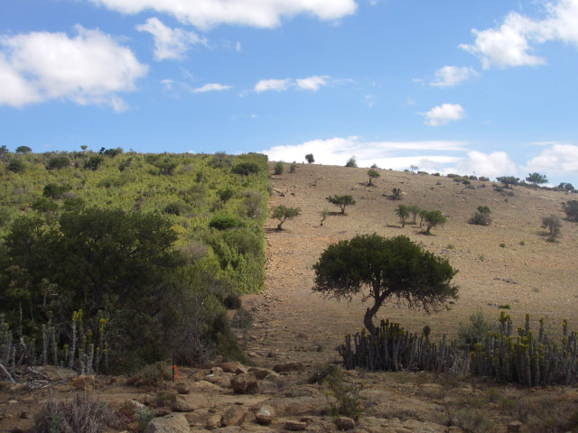

Figure 1.1 Intact and degraded subtropical thicket

Source: (Restoration Research Group 2012)

There is considerable interest in actively restoring degraded thicket habitat for several reasons. *P. afra* is unusually effective at storing carbon compared to other arid region vegetation. Measurements at a number of sites indicate that average rates of carbon storage lie between 1.2 and 4.2 t C ha-1 yr-1 (Van der Vyver et al. 2013; Mills & Cowling 2006). Further measurements in Van der Vyver et al. (2013) support these figures. Comparison of degraded and intact sites has shown that restoration could sequester the order of 100 t C ha-1 (Van der Vyver et al. 2013; Mills et al. 2005; Marais, Cowling & Powell 2009). These numbers compete with the carbon storage capacity of mesic forests (Mills et al. 2005). Carbon captured through restoration of *P. afra* can be traded as credits on the international carbon market. Using this as a source of funding for landscape-scale restoration is economically viable (Mills et al. 2007; Marais, Cowling & Powell 2009). *P. afra* has the uncommon ability to switch between C3 and CAM photosynthetic systems depending on season (Guralnick & Ting 1986). This means it is productive year-round which likely contributes to its substantial sequestration abilities (Mills & Cowling 2010). *P. afra* propagates vegetatively and can thus be grown from cuttings (Stuart-Hill 1992) which means that costs of restoration can be reduced by avoiding nursery expenses (Mills & Cowling 2010).

Subtropical Thicket provides an important source of food for many herbivores, including domesticated livestock (Thompson et al. 2009; Vlok, Cowling & Wolf 2005). Re-establishment of *P. afra* in degraded areas will help prevent soil erosion, reduce flood severity and improve water quality (Van Luijk et al. 2013; Mills & Cowling 2006). It is also attractive from an employment perspective; potentially creating thousands of jobs in impoverished areas, if implemented on a large scale. Increased biodiversity could help improve income from tourism and provide sustained access to wood, fruit and medicines for local communities (Mills et al. 2007).

The dense canopy of *P. afra* facilitates an accumulation of soil organic matter which in turn significantly improves the water-holding capacity and fertility of the soil (Adie & Yeaton 2013; Mills & Cowling 2010; Lechmere-Oertel et al. 2008; Mills & Fey 2004). *P. afra* acts as a nurse plant. The provision of shade, improved soil quality and moisture retention, creates a favourable environment for other plants to germinate (Adie & Yeaton 2013; Mills & Cowling 2010). It has been observed that over a period of 40 to 50 years, woody canopy and other species re-establish in *P. afra* restoration areas to a degree that restored thicket is compositionally comparable to intact thicket (Van der Vyver et al. 2013). An investigation into the feasibility of accelerating the restoration of woody canopy species through planting in *P. afra* restoration sites was conducted, but it was found that survival rates were poor and restoration costs prohibitive (Vyver et al. 2012). It seems the most practical option for ecosystem restoration is to plant *P. afra* and allow other species to re-establish naturally through spontaneous recruitment (Mills et al. 2007).

Restoration research is being conducted as part of the Subtropical Thicket Restoration Project (STRP), which is an initiative of the Working for Woodlands Programme. “To evaluate methods of spekboom restoration, a partnership has been forged among scientists, government and an implementing agency. The South African government’s Working for Woodlands Programme … has engaged a group of scientists to assist in evaluating effective ways of using spekboom cuttings for restoration under different conditions …. The programme is being managed by an implementing agency, the Gamtoos Irrigation Board (GIB), rated as one of the best agencies used by Working for Water.” (Mills et al 2010: 9) *P. afra* restoration is also actively being conducted and monitored in the Baviaanskloof Nature Reserve, Addo Elephant National Park and the Fish River Reserve in the Eastern Cape (Mills et al. 2010). Approximately 1630 ha had been restored in these areas in 2012 (Vyver et al. 2012).

Supporting spatial information is needed to aid the *P. afra* restoration process. Candidate restoration areas need to be identified. There are many factors to consider when selecting appropriate sites (Curran et al. 2012; Knight et al. 2011). A map of *P. afra* canopy cover is a key input to this decision-making process. Canopy cover can be used to estimate the expected carbon storage resulting from restoration. This provides an indication of the economic feasibility of restoration. Measures of intact canopy cover in a similar habitat to the restoration area are used to determine an appropriate planting density. Restoration progress can be monitored by updating the canopy cover map over time which would also assist in the carbon accounting required for trading credits on the international market (Mills et al. 2010). The canopy cover map would also be a useful tool for deepening the present understanding of the Subtropical Thicket biome.

A detailed vegetation map of the Little Karoo has been created at a 1:50000 scale (Vlok, Cowling & Wolf 2005). Using this map, a degradation mapping study was conducted in the Little Karoo (Thompson et al. 2009). It was successful at using MODIS data to estimate intact, moderate and severe degradation levels of *P. afra* thicket at a 250m pixel resolution. Currently, there is an initiative to involve private land-owners in the restoration project in order to broaden its impact (Curran et al. 2012; Mills et al. 2010). Restoration planning at farm-level will require map scales of 1:10000 or better to provide sufficient spatial detail for working with expected stand sizes of the order of 50 hectares. To achieve sufficient accuracy for carbon storage estimations, it will be necessary to estimate canopy cover in finer detail than the three levels of degradation used in Thompson et al. (2009) and at a finer spatial resolution. There is thus a need to further the work of Thompson et al. (2009) to produce maps of both a higher spatial and canopy cover level resolution.

## SIGNIFICANCE AND RATIONALE

Measures of canopy cover can be used to infer biomass for individual species (Ludwig, Reynolds & Whitson 1975). In the context of climate change, biomass is an important variable for monitoring ecosystem carbon dynamics. Carbon absorbed by vegetation and soils will play a significant role in efforts to reduce atmospheric CO2 and in determining the development of future climate change (Eisfelder, Kuenzer & Dech 2012; Lu 2006). Canopy cover or biomass is also important from a perspective of understanding environmental processes and ecosystem services. Improved biomass is related to increased biodiversity (Lu 2006; Fabricius, Burger, and Hockey 2003), reduced erosion and improved soil fertility and water-holding ability (Eisfelder, Kuenzer & Dech 2012; Mills & Cowling 2010; Lechmere-Oertel et al. 2008; Mills & Fey 2004).

Under the Kyoto Protocol, ratified countries are legally bound to reduce CO2 emissions to capped levels. If these levels are exceeded, countries can make up the deficit by buying carbon credits from another country that was able to reduce its emissions below its target level (Mills et al. 2010). The Clean Development Mechanism (CDM) is a means by which developing countries can run sequestration projects and trade carbon credits on the international market. There are also the Voluntary Carbon Standard (VCS), Community and Climate and Biodiversity Standard (CCBS) which work on a similar basis to the CDM, but don’t require authorisation by the host country. Under these schemes there are legal provisions that require rigorous accounting of stored carbon. These measurements are time consuming and costly when performed manually (Eisfelder, Kuenzer & Dech 2012; Lu 2006). Canopy cover measurements are currently being done by visual inspection in the field. There is a need for greater accuracy and repeatability than is possible with this technique. A *P. afra* canopy cover map would serve as a first step towards achieving the required carbon storage measurements via remote sensing on a large scale.

The benefits of *P. afra* restoration are manifold and include benefits for local communities. The STRP has placed a strong emphasis on stakeholder engagement and community development (Marais, Cowling & Powell 2009). Restored areas will provide increased capacity for supporting judiciously managed livestock and employment for thousands of workers if restoration is implemented on a large scale (Mills et al. 2010). Employment is particularly relevant for the Eastern Cape where unemployment rates are amongst the highest in South Africa at roughly 27% (Statistics South Africa 2011).

This research presents a number of challenges from a technical remote sensing perspective. There is VHR (0.5m/pixel) multi-spectral data with national coverage available from Chief Directorate: National Geo-spatial information (NGI) (National Geo-spatial Information 2012). This imagery represents a rich source of information, but to date it has only been used for topographical mapping and photo-interpretation. To the best of the author’s knowledge, this is the first study to exploit this imagery for automated vegetation monitoring. Use of VHR imagery for estimation of environmental variables is fairly uncommon, especially over large areas such as the Little Karoo (Eisfelder, Kuenzer & Dech 2012; Lu 2006). Figure 1.2 shows an example colour infra-red (CIR) image of *P. afra* thicket from NGI.

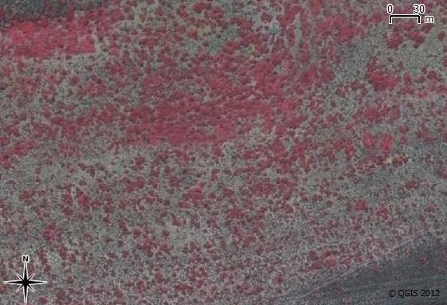

Figure 1.2 CIR Image of *P. afra* Thicket

Another aspect of this research that has been relatively unexplored in the literature is measuring some aspect of degradation, such as a reduction in canopy cover, in an arid environment. Research on measurement of indicators in forest ecosystems is fairly well established (Lu 2006; Wulder et al. 2004; Lévesque & King 2003). Arid regions present some remote sensing challenges not typically encountered in forests. These include the naturally sparse vegetation cover and mixing of soil and vegetation spectra (Eisfelder, Kuenzer & Dech 2012; Thompson et al. 2009). Arid regions cover roughly one third of the terrestrial land surface (Food and Agriculture Organization (FAO) 1989) and are particularly sensitive to degradation (Mills et al. 2005; Stuart-Hill 1992). Remote sensing techniques applicable to arid environments are therefore of importance.

Dealing with sources of unwanted variation is a recurring difficulty reported in the remote sensing literature (Eisfelder, Kuenzer & Dech 2012; Baraldi et al. 2010; Lu 2006). Achieving an accurate canopy cover mapping over a large spatial scale and using a mosaic of images acquired at different times requires an algorithm that is robust to many of the variations commonly encountered. These include topography, *P. afra* habitat and shadow variations. Dealing with these challenges has comprised a significant portion of the research effort.

## PROBLEM STATEMENT

Habitats supporting *P. afra* have been degraded by overgrazing over much of their range. There is significant interest and a growing body of research in *P. afra* restoration. Restoration projects will generate employment, restore ecosystem services and produce carbon credits that can be traded to offset restoration costs. There is a need for spatial information, in the form of *P. afra* canopy cover maps, to support restoration projects in the identification of suitable areas to plant and in the monitoring of restoration progress at repeated intervals. Restoration is planned for large areas of the Little Karoo and Eastern Cape. Map scales of at least 1:10000 are required to provide sufficient accuracy for farm-level restoration planning. The production of detailed, large scale *P. afra* canopy cover maps using manual (i.e. image interpretation) methods is prohibitively time-consuming and expensive, particularly for large areas such as the Little Karoo. An automated or semi-automated image analysis technique that is robust enough to deal with the inherent temporal, topographical and radiometric variations in VHR aerial imagery is needed to monitor *P. afra* canopy cover dynamics in the Little Karoo.

## RESEARCH AIM AND OBJECTIVES

The research aim is to develop an automated or semi-automated image analysis technique to accurately estimate *P. afra* canopy cover in pristine and transformed areas using very high resolution (VHR) aerial imagery, covering large areas.

To achieve the research aim, the following objectives have been set:

1. Review the literature on *P. afra* restoration, vegetation and canopy cover mapping in arid environments, as well as vegetation and canopy cover mapping using VHR imagery.
2. Carry out a field study to establish suitable reference sites and determine the actual (ground truth) canopy cover for each site.
3. Source, rectify and radiometrically calibrate aerial imagery from NGI.
4. Develop a classifier that accurately distinguishes *P. afra* from surrounding vegetation.
5. Apply the classifier to imagery of the study area and interpret and evaluate the results.

## STUDY AREA

The Little Karoo as defined in Vlok, Cowling & Wolf (2005), was selected as the area of interest. It is a semi-arid region of great biodiversity lying between two mountain ranges. Three biomes considered to be biodiversity hotspots of global significance intersect in the Little Karoo (Thompson et al. 2009). A total of 54 habitat types were identified by Vlok, Cowling & Wolf (2005) in their vegetation map, of which ten support *P. afra*. Subtropical Thicket can occur in a continuous extent or as solid clumps against a background of another vegetation type, termed the “mosaic”. The Subtropical Thicket biome makes up 35.3% of the Little Karoo which has a total area of 2 343 900 ha (Vlok, Cowling & Wolf 2005). It was found that 89.3% of the *P. afra* thicket was degraded to some extent in a study area comprising roughly half the area of the Little Karoo (Thompson et al. 2009). The Little Karoo was chosen as a study area because it contains a significant portion of *P. afra* suited and degraded habitat and has been targeted for restoration. It is also beneficial that a number of relevant studies have been performed in the area (Thompson et al. 2009; Forsyth, Vlok & Reyers 2008; Vlok, Cowling & Wolf 2005).

To expedite computing times and reduce storage space required for the VHR imagery, a smaller portion of the Little Karoo was chosen as the study area (Figure 1.3). This area was chosen to be as representative of the variation in the Little Karoo as possible. It consists of four different aerial survey campaigns flown at different times and thus still poses a challenge from a remote sensing perspective. It also includes examples of all the different biomes and nine of the ten habitat types supporting *P. afra* as defined by Vlok, Cowling & Wolf (2005).

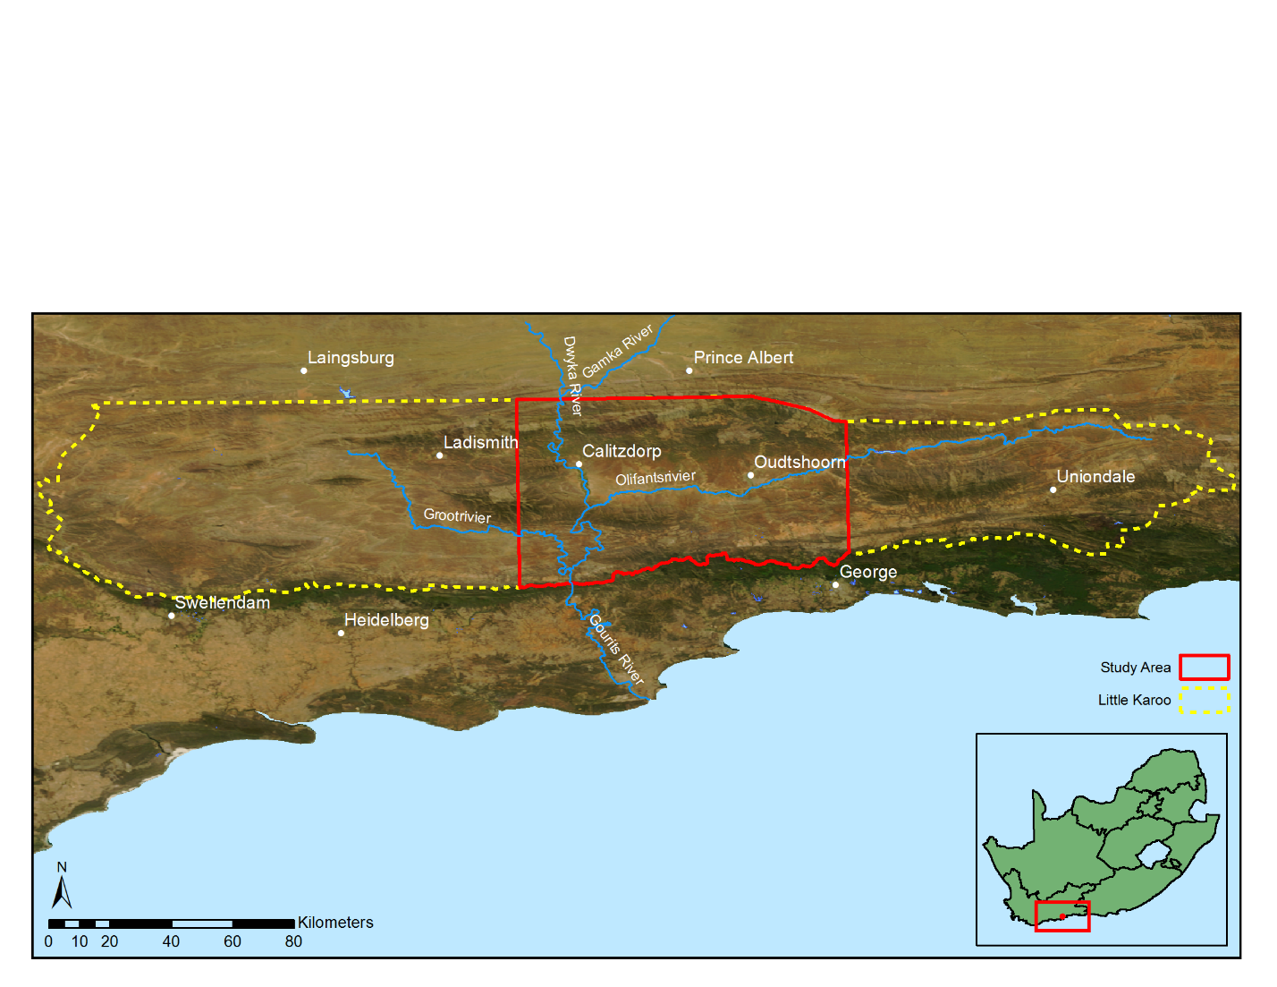

Figure 1.3 Location of the study are within the Little Karoo

## METHODOLOGY

Canopy cover estimations are currently being conducted manually using visual inspection in the field. While this is a common approach for measuring environmental indicators, it is time consuming and only practical for small areas (Eisfelder, Kuenzer & Dech 2012; Lu 2006). A visual inspection is also prone to repeatability issues due to the subjectivity of the inspector. *P. afra* restoration is envisioned for large areas of the Eastern Cape and Little Karoo and will require monitoring of plant growth over time. Repeatability and accuracy constraints on carbon measurements are stringent in order to achieve the necessary accreditation for carbon trading in schemes like the CDM. This research investigates the use of quantitative remote sensing methods for estimating *P. afra* canopy cover. Remote sensing methods are common for biomass estimation (Eisfelder, Kuenzer & Dech 2012; Lu 2006) and is chosen as it will facilitate accurate canopy cover estimation of large areas and at repeated intervals. Using the categorisation of Mouton (2001), this research can be regarded as a methodological study that is experimental in nature. The research design is shown in Figure 1.4 and detailed in the following chapters.

An empirical approach was used for developing the canopy cover estimation. Various secondary measurements or features were extracted from the remotely sensed data and used to build a model of *P. afra* canopy cover. Similar approaches for measuring degradation or biomass in an arid environment were successful in Thompson et al. (2009) and Ludwig, Reynolds & Whitson (1975). The accuracy of the model was tested against unseen data as a check against overfitting (Jain, Duin & Mao 2000).

This work is intended to be applied research. Emphasis was placed on producing a map that is both useful and usable (Pierce et al. 2005). This required interaction and communication with stake-holders (Knight et al. 2011), specifically environmental practitioners currently involved in performing canopy cover assessments, the STRP and the GIB, who are the restoration implementing agents (Mills et al. 2010).

There is a tendency for environmental remote sensing to be conducted in an isolated way that does not allocate adequate importance to understanding complex human and ecological processes affecting the data being analysed (Hein et al. 2011; Turner 2003). This naïve approach can lead to models that do not generalise well over varying spatial and temporal conditions. Recognition of the value of multi-disciplinary teams incorporating expert knowledge of local conditions and field experience is given in Knight et al. (2011) and Thompson et al. (2009). This research was undertaken in collaboration with a botanist, Jan Vlok, who has a wealth of experience in the Little Karoo (Thompson et al. 2009; Forsyth, Vlok & Reyers 2008; Vlok, Cowling & Wolf 2005) and with *P. afra* in particular. His insight into local habitat variations and involvement in restoration work was invaluable to the study.

The technical details of radiometric calibration, feature selection and classification are contained in Chapters 2, 3 and 4 respectively. These chapters were written as papers to be submitted to appropriate scientific journals. Short literature reviews and further details on the methodology relevant to each topic are provided in their respective chapters. It was necessary to repeat some material in these chapters to make them coherent in isolation.

Literature review

Imagery acquisition/ preparation

Radiometric calibration

Calibration validation

Classifier design

Interpretation and evaluation

Evaluate imagery suitability

Figure 1.4 Research design

# Retrieval of Surface Reflectance From Aerial Imagery By CalibratiON with Satellite Data

## ABSTRACT

While VHR aerial imagery holds great potential for quantitative remote sensing, its use has been limited by unwanted radiometric variation over temporal and spatial extents. In this paper we propose a simple, yet effective technique for transforming the digital numbers of aerial images to surface reflectance values. A collocated and concurrent well calibrated satellite image is used as a surface reflectance reference to which the images are calibrated. The reference satellite sensor needs to be spectrally similar to the aerial sensor and aerial and satellite imagery should have been acquired at similar times. It is shown that a spatially varying local linear model can be used to approximate the relationship between the surface reflectance of the reference image and digital numbers of the aerial images. The model parameters are estimated, for each satellite pixel location, using least squares inside a small sliding window. The technique was applied to a set of 2228 overlapping aerial images captured with an Intergraph DMC camera. A near-concurrent MODIS MCD43A4 image was used as the reflectance reference dataset. The resulting DMC mosaic was compared to a near-concurrent SPOT 5 reflectance image of the same area, and the mean absolute reflectance difference was found to be 4.18%, which is similar to the accuracy of other aerial image correction methods. The technique implicitly corrects for atmospheric and coarse-scale bidirectional reflectance distribution function (BRDF) effects, does not require spectral measurements of field sites or placement of known reflectance targets and produces seamless mosaics. Due to its relative simplicity and computational efficiency, it is an attractive alternative to existing calibration methods.

## INTRODUCTION

VHR aerial and drone imagery is increasingly being used in remote sensing studies. The high spatial resolution of these images enables analyses on a finer spatial scale than most satellite based platforms can provide and consequently allows the exploitation of information such as texture, object-based features and unmixed pixel spectra that is not available in lower resolution images (Markelin et al. 2012; Collings et al. 2011; López et al. 2011; Chandelier & Martinoty 2009; Honkavaara et al. 2009). Accurate geometric calibration techniques for producing orthorectified images are well established and form part of typical aerial imagery processing workflows (Chandelier & Martinoty 2009). Extraction of surface reflectance from aerial imagery is, however, still a challenge. Spatial and temporal radiometric variations in aerial imagery limit the extent over which quantitative remote sensing techniques can be successfully applied (Markelin et al. 2012). Atmospheric influences, bidirectional reflectance distribution function (BRDF) effects and sensor variations all contribute to radiometric variations in the imagery. To obtain surface reflectance, these radiometric variations must be reduced as far as possible.

There is some confusion and ambiguity around the use of reflectance terminology in the literature (Schaepman-Strub et al. 2006). In this paper “surface reflectance” is used to mean the bi-directional surface reflectance at local solar noon and viewed at nadir. It is worth noting that as it is not possible or practical to correct for all the sources of radiometric variation in aerial imagery and that surface reflectance in most so-called “corrected” or “calibrated” images is only an approximation to the actual value.

Aerial image mosaics are commonly produced for the purpose of visual interpretation. Techniques such as dodging and look up tables (LUTs) are often used to produce a smooth and visually appealing mosaic (López et al. 2011). This kind of adjustment can damage the spectral information content and is not suited to quantitative remote sensing. A number of techniques for the correction of BRDF effects are available, including the popular kernel-based method (Roujean, Leroy & Deschamps 1992). Approaches based on radiometric transfer modelling (RTM), such as ATCOR (Richter 1997), MODTRAN (Berk et al. 1999) and 6S (Vermote et al. 1997) are used for atmospheric correction. While these atmospheric and BRDF correction methods are effective on single images (Markelin et al. 2012), blocks of multiple aerial images present new challenges. The large view angles of aerial imaging cameras cause the solar and viewing geometries to vary significantly through the image (Lelong et al. 2008). Aerial campaigns are usually carried out over multiple days resulting in significant variation in BRDF and atmospheric conditions. Each land cover also has its own unique BRDF and corrections should ideally model each of these covers separately (Collings et al. 2011; Honkavaara et al. 2009). Techniques that account for land cover specific BRDF’s require an upfront cover classification which is time-consuming and introduces another potential source of error. Aerial campaigns can also consist of thousands of images making it impractical to apply time consuming atmospheric and BRDF correction models to every image (López et al. 2011). Even if it was practical, remnant radiometric variation due to the inexact nature of BRDF and atmospheric corrections will result in discontinuities, or seam lines, between adjacent images.

Approaches to calibrating mosaics of aerial imagery are receiving increasing attention (López et al. 2011; Collings et al. 2011; Gehrke 2010; Chandelier & Martinoty 2009). All of these approaches exploit the fact that adjacent images contain significant portions of overlap and that in a perfectly calibrated mosaic, these overlapping portions of different images should be identical. Collings et al. (2011) introduced a spatially varying linear model to perform combined atmospheric and BRDF correction. The parameters of the model are solved by minimising a cost function that includes costs for internal accuracy of each image, similarity of overlapping image regions and smoothness (i.e. the lack of seam lines) of the mosaic. In a second stage the entire mosaic is calibrated to absolute reflectance using specially placed ground targets with known reflectance. In Chandelier & Martinoty (2009) a simple three parameter model of the combined atmospheric and BRDF effects is fitted by minimising the difference between “radiometric tie-points”, which are a selection of points in the overlapping image regions. It is a relative calibration method and no adjustment to absolute reflectance is made. A similar approach is used in López et al. (2011). Gehrke (2010) uses standard atmospheric and BRDF methods followed by a relative radiometric normalisation (RRN) step using invariant points in overlapping regions to smooth the mosaic.

A disadvantage of the aerial mosaic calibration techniques described above is their complexity and need for known ground references to achieve transformation to absolute surface reflectance. Transformation to an absolute physical quantity such as reflectance is beneficial as this is an invariant property of the surface which allows the data to be used in physical models, fused with other reflectance data and used in multi-temporal studies (Downey et al. 2010; Vicente-Serrano, Pérez-Cabello & Lasanta 2008). The options of placing targets of known reflectance to be captured as part of the mosaic or measuring the reflectance of suitably invariant sites on the ground are often not possible or practical. Many applications make use of archived imagery that had been captured prior to the commencement of the research and for which concurrent ground measurements are consequently not possible. Another approach is to make use of vicarious calibration involving knowledge of the spectral characteristics of specific ground sites, but this is recognised as being labour-intensive and costly (Gao et al. 2013; Chander, Meyer & Helder 2004; Liu et al. 2004).

In this paper, we propose a method of extracting surface reflectance from aerial imagery by calibrating to a concurrent and collocated surface reflectance satellite image. It avoids the need to perform time consuming and complex atmospheric and BRDF corrections explicitly by using a reference image that has already been corrected for these effects using a well-established process. It also avoids the need for placement of known reflectance targets or field spectral measurements which can be impractical and time-consuming in many instances. This procedure borrows conceptually from the field of cross calibration (Liu et al. 2004; Teillet et al. 2001), where one uncalibrated satellite sensor is calibrated to another well-calibrated satellite sensor using concurrent images of an area of known surface reflectance. It can also be considered a form of data fusion (Pohl & Van Genderen 1998) in that it is fusing high resolution DN data with and coarse resolution surface reflectance data to obtain high resolution surface reflectance data. This process is not without its limitations and assumptions, which will be discussed in the following section.

## METHODS

### FORMULATION

Combined BRDF, atmospheric and sensor corrections can be modelled as a spatially varying linear relationship between surface reflectance and sensor measurement. Following the notation of López et al. (2011), the aerial sensor measurement for each band can be expressed as:

|  |  |  |
| --- | --- | --- |
| $$DN=c_{0}L_{s}+c_{1}$$ |  | (2.1) |

where $DN$ is the sensor measurement, $L_{s}$ is the radiance at the sensor and $c_{0}$ and $c_{1}$ are coefficients determined by the characteristics of the sensor. The radiance at the sensor is expressed as:

|  |  |  |
| --- | --- | --- |
| $$L_{s}=\frac{ρ_{s}E_{s}cosθ}{π}$$ |  | (2.2) |

where $ρ_{s}$ is the reflectance at the sensor, $E_{s}$ is the top of atmosphere (TOA) irradiance and $θ$ is the solar zenith angle. The reflectance at the sensor is described by the radiative transfer equation (Vermote et al. 1997):

|  |  |  |
| --- | --- | --- |
| $$ρ_{s}=ρ_{a}+\frac{ρ_{t}}{1-Sρ_{t}}τ_{↑}τ_{↓}τ_{g}$$ |  | (2.3) |

where $ρ_{a}$ is the atmospheric reflectance, $ρ_{t}$ is the surface reflectance and $S$ is the atmospheric albedo. $τ_{↑}$ and $τ_{↓}$ are the atmospheric transmittances due to molecular and aerosol scattering between the surface and sensor and between the sun and the surface respectively and $τ_{g}$ is the global atmospheric transmittance due to molecular absorption. The atmospheric albedo, $S$, is typically around 0.07 (Manabe & Strickler 1964). With a small value for $S$, the denominator in Equation (2.3) is approximately one and the reflectance at the sensor can be approximated as:

|  |  |  |
| --- | --- | --- |
| $$ρ_{s}≃ρ_{a}+ρ_{t}τ_{↑}τ_{↓}τ_{g}$$ |  | (2.4) |

Equations (2.1), (2.2) and (2.4) express the relationship between the sensor measurement, atmospheric conditions and the surface reflectance. Note that the surface reflectance is subject to BRDF effects and so also varies with the viewing geometry. With the approximation of Equation (2.4), there is a linear relationship between surface reflectance and the sensor measurement. The parameters of this relationship are dependent on the atmospheric conditions and viewing geometry, and vary spatially and temporally. This linear relationship can be expressed as:

|  |  |  |
| --- | --- | --- |
| $$DN=Mρ_{t}+C$$ |  | (2.5) |

where

|  |  |  |
| --- | --- | --- |
| $M={\frac{1}{π}c}_{0}τ_{↑}τ_{↓}τ_{g}E_{s}cosθ$ |  | (2.6) |

and

|  |  |  |
| --- | --- | --- |
| $C={c_{1}+\frac{1}{π}c}_{0}ρ_{a}E_{s}cosθ$ |  | (2.7) |

The parameters $M$ and $C$, are spatially varying functions of the viewing geometry and atmospheric conditions. Use of a local linear relation to model radiative transfer is also advocated in Collings et al. (2011) and Gehrke (2010). Implicit in any radiometric calibration technique is an approximation of these parameters so that the relationship can be inverted.

In our proposed method, we solve for $M$ and $C$ of the aerial sensor using a reference estimate for the surface reflectance parameter, $ρ_{t}$, obtained from a well calibrated satellite image. The reference surface reflectance image should have been captured at a similar time to the uncalibrated aerial image(s) to avoid phenological or structural differences between the reference and uncalibrated images. The reference image will typically be at a significantly lower spatial resolution than the aerial imagery. Calibrated surface reflectance products, such as those produced from MODIS and MISR, have resolutions of the order of 500m while aerial images usually have resolutions of 2m or higher. This large resolution discrepancy is not ideal, but it is assumed that atmospheric and BRDF effects vary little at a small spatial scale and that the reference resolution is sufficient to capture gradual variations in atmospheric conditions and BRDF.

Least squares estimates of $M$ and $C$, for the aerial sensor, are found for each pixel of the reference image inside a sliding window, as described by Equation (2.8).

|  |  |  |
| --- | --- | --- |
| $$\left[\begin{matrix}M \\ C\end{matrix}\right]={\left[\begin{matrix}ρ_{t} & 1\end{matrix}\right]}^{-1} DN$$ |  | (2.8) |

where $ρ_{t}$ and $DN$ are row vectors of the *N* values inside the sliding window and $1$ is a row vector of ones of length *N*. is obtained from the reference image and $DN$ from the aerial image(s). The sliding window should consist of at least two pixels to solve for the two parameters. In circumstances where the camera offset,, is zero and atmospheric reflectance, $ρ_{a}$, is small, *C* may be regarded as being sufficiently small to be omitted from the model, in which case a sliding window of one pixel may be used. In order to accommodate the differing spatial resolutions, $M$ and $C$ must be found at the reference spatial resolution, resampled to the aerial spatial resolution, and then used to estimate surface reflectance at this resolution by inverting the relationship of Equation (2.5).

The procedure follows these steps:

1. The uncalibrated aerial images are resampled to the reference image resolution and grid.
2. Estimates of $M$ and $C$ are found for each pixel of each band of the reference image using Equation (2.8). This forms two multi-band rasters **M** and **C**.
3. The **M** and **C** rasters are resampled to the aerial image resolution and grid.
4. The surface reflectance is estimated for each pixel of each band of the uncalibrated aerial image, using Equation (2.5).

It is important to note that the proposed method assumes the spectral responses of the reference and uncalibrated sensors are identical. In practice, this obviously does not hold true. The relation between surface reflectance and sensor measurement in Equation (2.5) becomes non-linear when including the spectral response effect. The surface reflectance in Equation (2.5) is a band-averaged quantity as represented by Equation (2.9).

|  |  |  |
| --- | --- | --- |
| |  | (2.9) |

where $ρ_{t}(λ)$ is the spectral surface reflectance and $R(λ)$ is the sensor relative spectral response (RSR) for a particular band. Without knowledge of the surface reflectance spectra, it is not possible to completely calibrate for this effect. It can however often be shown that for real world surface reflectances, the relationship between the band averaged values for different sensors is approximately linear (Gao et al. 2013; Jiang & Li 2009). Practically, this means the relationship between surface reflectance and sensor measurement remains approximately linear even when including the sensor spectral response. Although the calibration method proposed in this paper does not explicitly compensate for sensor spectral responses, it is assumed that the effect is locally linear and will consequently be incorporated into the model of Equation (2.5). This assumption is supported with simulations for the case study sensors in Section 2.4.1.

The choice of resampling algorithms in steps 1 and 3 of the procedure are important. This is especially true when there is a large difference in the spatial resolution of the aerial and reference images. Optical imaging systems are linear and thus subject to the superposition principle which manifests as spectral mixing. When downsampling in step 1, averaging the uncalibrated image over each reference pixel area is recommended. This will approximate the spectral mixing that occurs in the larger reference image pixels, although it does not account for the sensors’ differing point spread functions (PSF’s). The PSF effect is assumed to be minor. Standard interpolation algorithms were tested for efficacy when upsampling in step 3. It is necessary to produce smooth **M** and **C** rasters in this step to satisfy the assumption of slowly varying atmospheric and BRDF effects and to avoid discontinuities in the final image(s). Cubic spline interpolation, with its constraints of continuity of the first and second derivatives, was found to best satisfy this requirement. The Geospatial Data Abstraction Library (GDAL) (GDAL Development Team 2014) was used for implementing the resampling.

Blocks of aerial surface reflectance images generated with this procedure can be mosaicked without the need for additional colour balancing or normalisation procedures to reduce seam lines. A single reference satellite image will typically cover many aerial images and aerial images calibrated with this single reference will naturally tend to combine into a seamless mosaic. As described below, consideration must however be given to treatment of boundary pixels in steps 1 and 3 to minimise the formation of seam lines in the mosaic.

When downsampling to the reference resolution in step 1, reference resolution boundary pixels, in the downsampled image that are only partially covered by aerial resolution pixels should be discarded. For heterogenous land covers, these partially covered pixels would produce skewed estimates of *M* and *C*. The condition of complete coverage can be relaxed somewhat to reduce discarded pixels. A condition of at least 90 percent coverage was used for our case study. When upsampling to the aerial resolution in step 3, the GDAL spline interpolator extrapolates pixels that lie outside the polygon formed by the centres of the reference resolution boundary pixels. This can cause discontinuities between adjacent images where extrapolation is inaccurate. Boundary conditions can be imposed on the spline interpolation to guarantee continuity between adjacent images, but if there is sufficient overlap between adjacent images, a simpler option is to discard the extrapolated boundary pixels before forming the mosaic. This is the approach that was adopted for the case study.

### STUDY SITE, DATA COLLECTION AND PREPARATION

The surface reflectance retrieval method proposed in this paper was tested in a 96km x 107km area in the Little Karoo in South Africa as shown in green in Figure 2.1. Very high resolution (VHR) 0.5m/pixel multi-spectral aerial imagery was acquired from the Chief Directorate: National Geo-spatial Information (NGI), a component of the South African Department of Rural Development and Land Reform. The imagery was captured with a multispectral Intergraph DMC camera with red, green, blue and near-infrared (NIR) channels. The study site is covered by 2228 images captured during four separate aerial campaigns flown over multiple days from 22 January 2010 to 8 February 2010. The site was selected as the calibration work forms part of a larger vegetation mapping study being done in the area. The rectified imagery currently available from NGI has LUT and dodging adjustments made to it and is not suited to quantitative remote sensing. Thus, the raw imagery was obtained and corrected for lens distortion, band spatial alignment, sensor non-linearity and dark current using the Intergraph Z/I Post-Processing Software (PPS). The PPS corrected imagery was orthorectified using existing aero-triangulation data supplied by NGI.

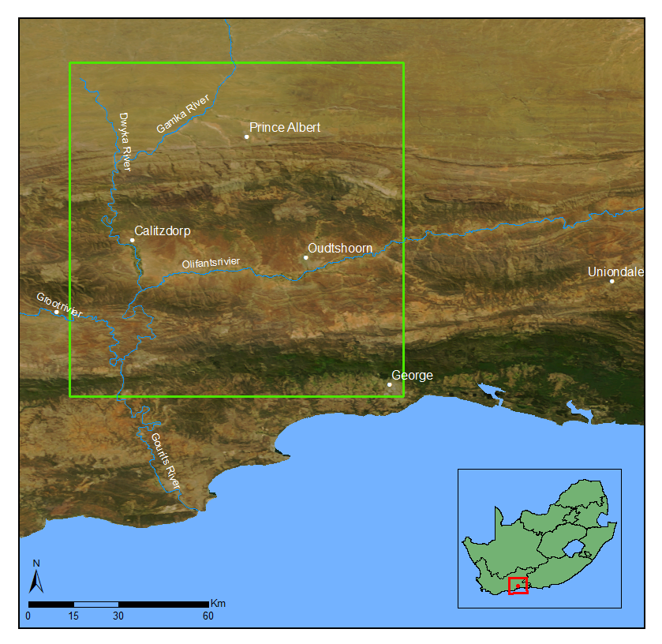

Figure 2.1 Study area orientation map

A MODIS MCD43A4 composite image for the period from 25 January 2010 to 9 February 2010 was selected as a reference for the cross calibration. This image has a 500m resolution and contains nadir BRDF-adjusted reflectance (NBAR) data composited from the best values over a 16 day period. The MODIS NBAR data has been processed with atmospheric and BRDF correction procedures (Strahler et al. 1999) and is recognised as a reliable reference source for cross calibration (Gao et al. 2013; Li, Yang & Wang 2012; Jiang & Li 2009; Liu et al. 2004). The NBAR data accuracy has been verified in a number of studies (MODIS Land Team 2014). It was also selected as it has similar spectral bands to the Intergraph DMC. Bands 4, 1, 3 and 2 are used from the MODIS sensor to correspond to the red, green, blue and NIR bands from the DMC sensor respectively. from(2.7)was assumed to be was used

### ACCURACY ASSESSMENT

Given that the imagery was acquired in 2010, it was not possibly to assess the accuracy of the reflectance retrieval method using ground-based spectral measures. Alternative methods for evaluating the results were used. Firstly, the DMC DN and calibrated surface reflectance images were stitched into mosaics and the mosaics were visually compared to determine if discontinuities between adjacent images were reduced and to what extent the radiometric variations were corrected. Secondly, the DMC surface reflectance mosaic was resampled to the MODIS grid and resolution and statistically compared to the MODIS reference image.

Lastly, we quantitatively compared the DMC surface reflectance mosaic to . The 10m resolution SPOT 5 level 1A image, acquired on 21 January 2010, covers portions of all four aerial campaigns as shown in 2.2. The image was ortho-rectified using a 5m resolution digital elevation model (Van Niekerk 2014). The SPOT 5 DN image was converted to surface reflectance using the Amospheric/Topographic CORrection (ATCOR-3) method (Richter 1997). Since the SPOT sensor does not have a blue band, it was omitted from this validation. The resulting surface reflectance image was statistically compared to the DMC surface reflectance mosaic and a difference image generated using Equation (2.10).

|  |  |  |
| --- | --- | --- |
| |  | (2.10) |

where is the DMC mosaic, $I^{SPOT}$ is the SPOT 5 image, $(x,y)$ are the pixel co-ordinates and $E$ is the difference image. The difference image was used to identify spatial patterns in the discrepancies between the corrected SPOT 5 image and DMC mosaic. The SPOT resolution of 10m allows the surface reflectance result to be checked at a resolution significantly closer to the aerial resolution than the reference MODIS resolution. This provides a useful check of the assumption that BRDF and atmospheric variations occur gradually and can thus be approximated at the coarse scale of the reference image. While the MODIS comparison is checking the DMC surface reflectance against the reference it was fitted to, the SPOT comparison is using an independent and “unseen” source.

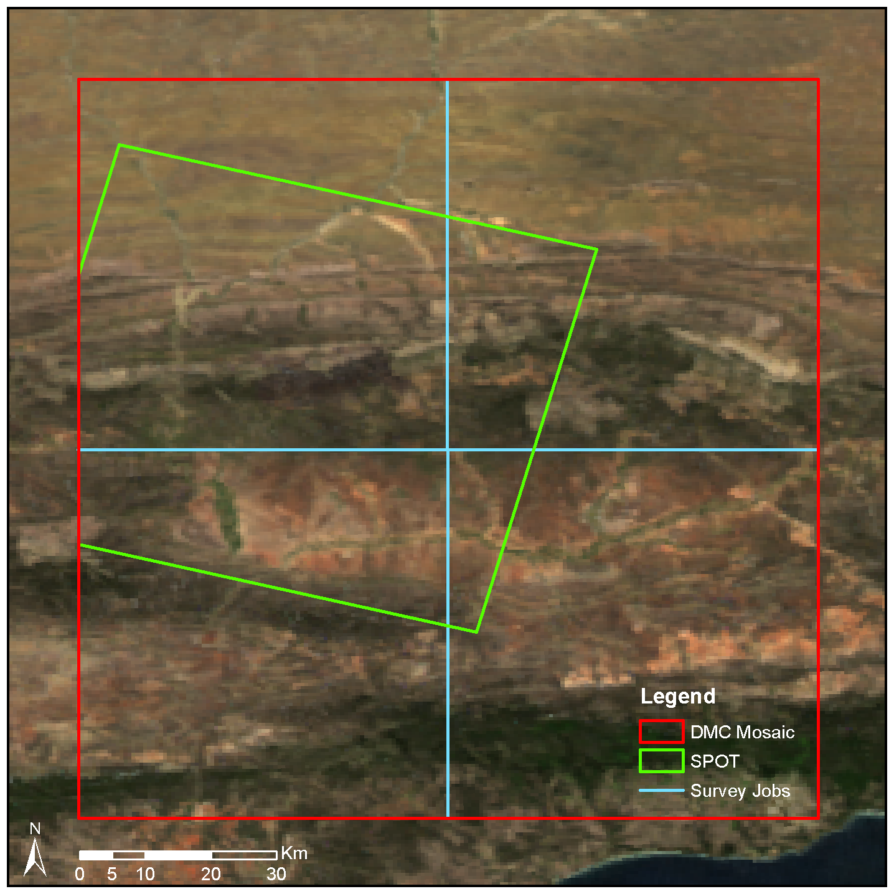

2.2



## RESULTS AND DISCUSSION

### Band Averaged Relationships

The RSR’s of the DMC and MODIS sensors are shown in Figure 2.3. While the assumption of identical RSR between the two sensors is obviously not satisfied, the peak overlap between the sensors is good in all bands with the exception of NIR.

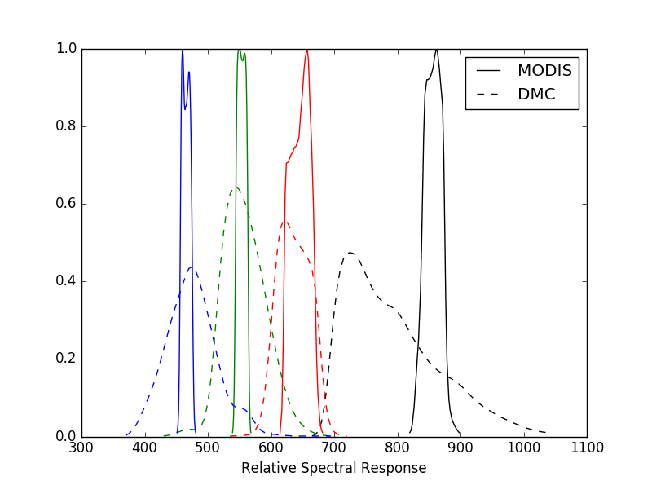

Figure 2.3 DMC and MODIS RSR’s

Band averaged values were simulated using typical surface reflectance spectra obtained from the ASTER spectral library (Baldridge et al. 2009). Twenty spectra were selected from the “soil”, “vegetation”, “water” and “man-made” classes to represent commonly encountered land covers. These were used with the sensor RSR’s in Equation (2.9) to simulate the band averaged values for each sensor. The measured band-averaged reflectance relationship between the two sensors is shown in Figure 2.4 with $R^{2}$ values. The correlation between the DMC and MODIS band-averaged values is surprisingly strong considering the disparity between the RSR’s. This correlation occurs as most real-world reflectance spectra are reasonably consistent within any one band. The band averaging effect for these sensors can therefore be incorporated into the linear reflectance model of Equation (2.5), as suggested in the previous section. As the proposed method only requires the relationship to be locally linear, the variety of land covers simulated here is unlikely to be present inside the sliding window used to estimate the model parameters. One can expect the correlation of the band averaged values to be stronger than the representation of Figure 2.4 for a small sliding window.

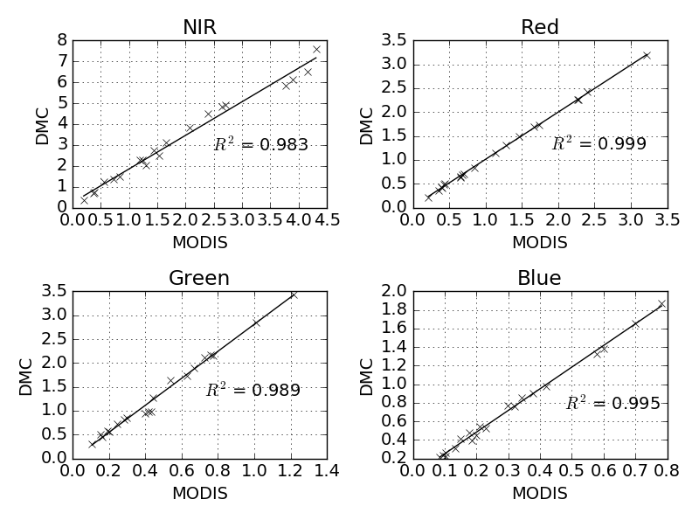

Figure 2.4 DMC vs. MODIS band averaged relationship for typical surface reflectances

### Mosaicking

Figure 2.5 shows a RGB mosaic of DMC DN images (bordered in red), against a background of the MODIS reference image. Seam lines between adjacent DMC images and radiometric variations over the set of images are clearly visible.

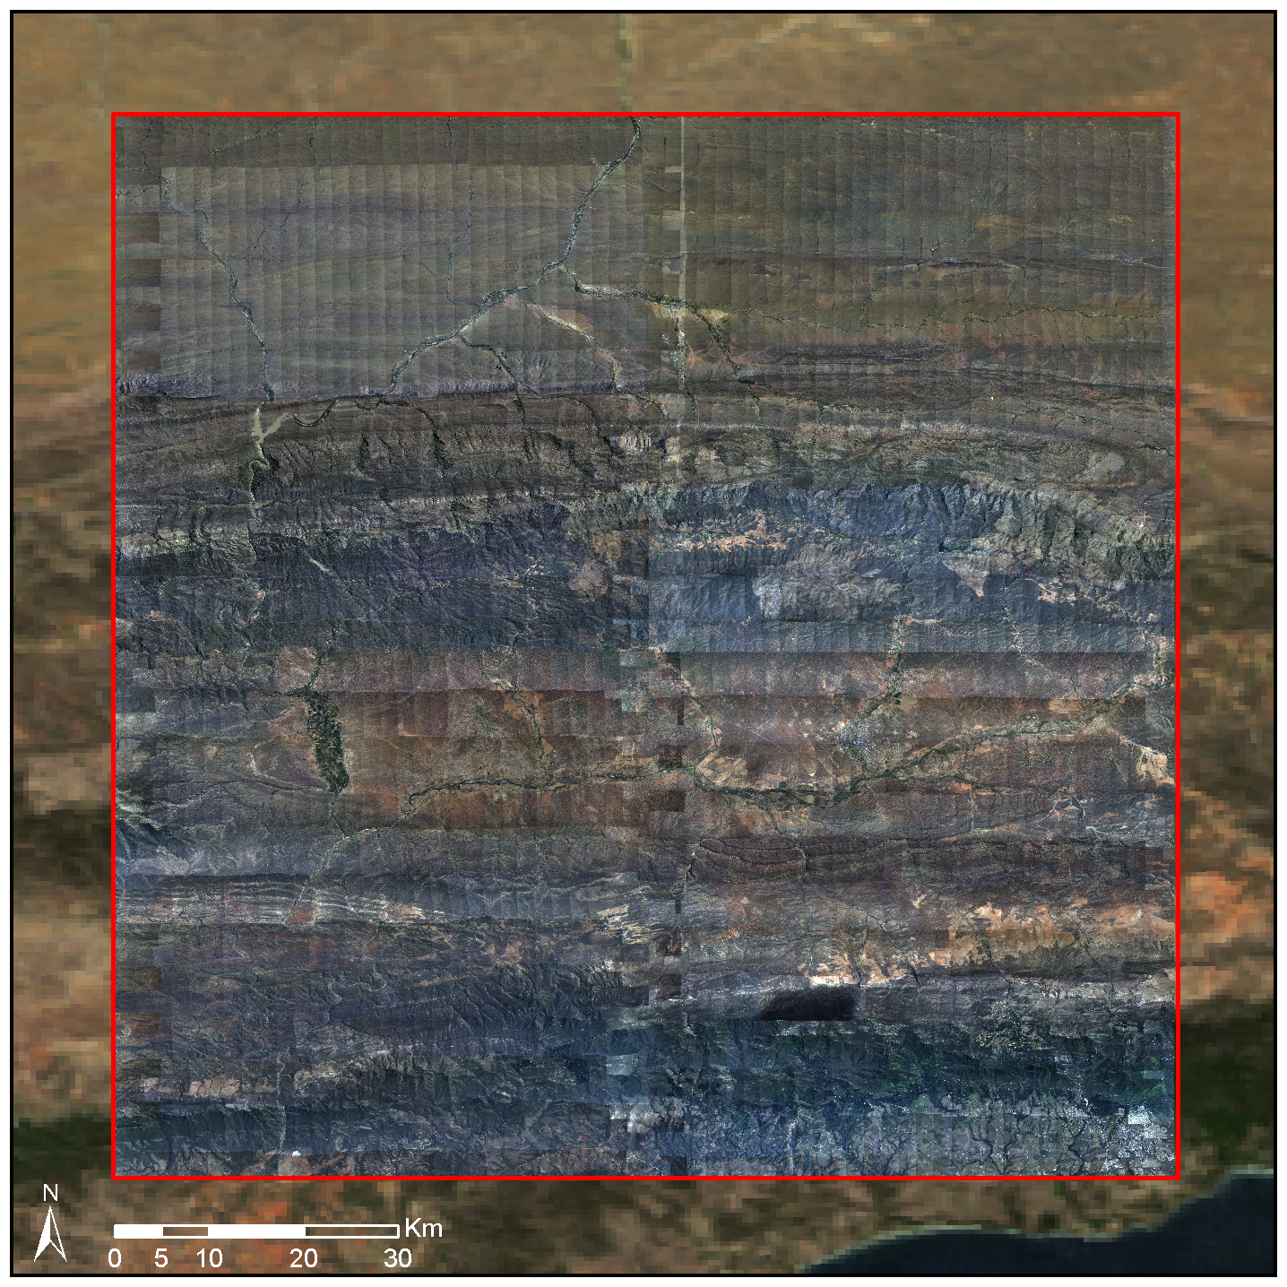

Figure 2.5 Camera calibrated mosaic on MODIS reference image background

Each DMC image was converted to surface reflectance using the proposed procedure. A RGB mosaic of the imagesisFigure 2.9Nseam lines or radiometric issues like hot spots are apparent at this scale, the corrected images the reflectance of the MODIS reference

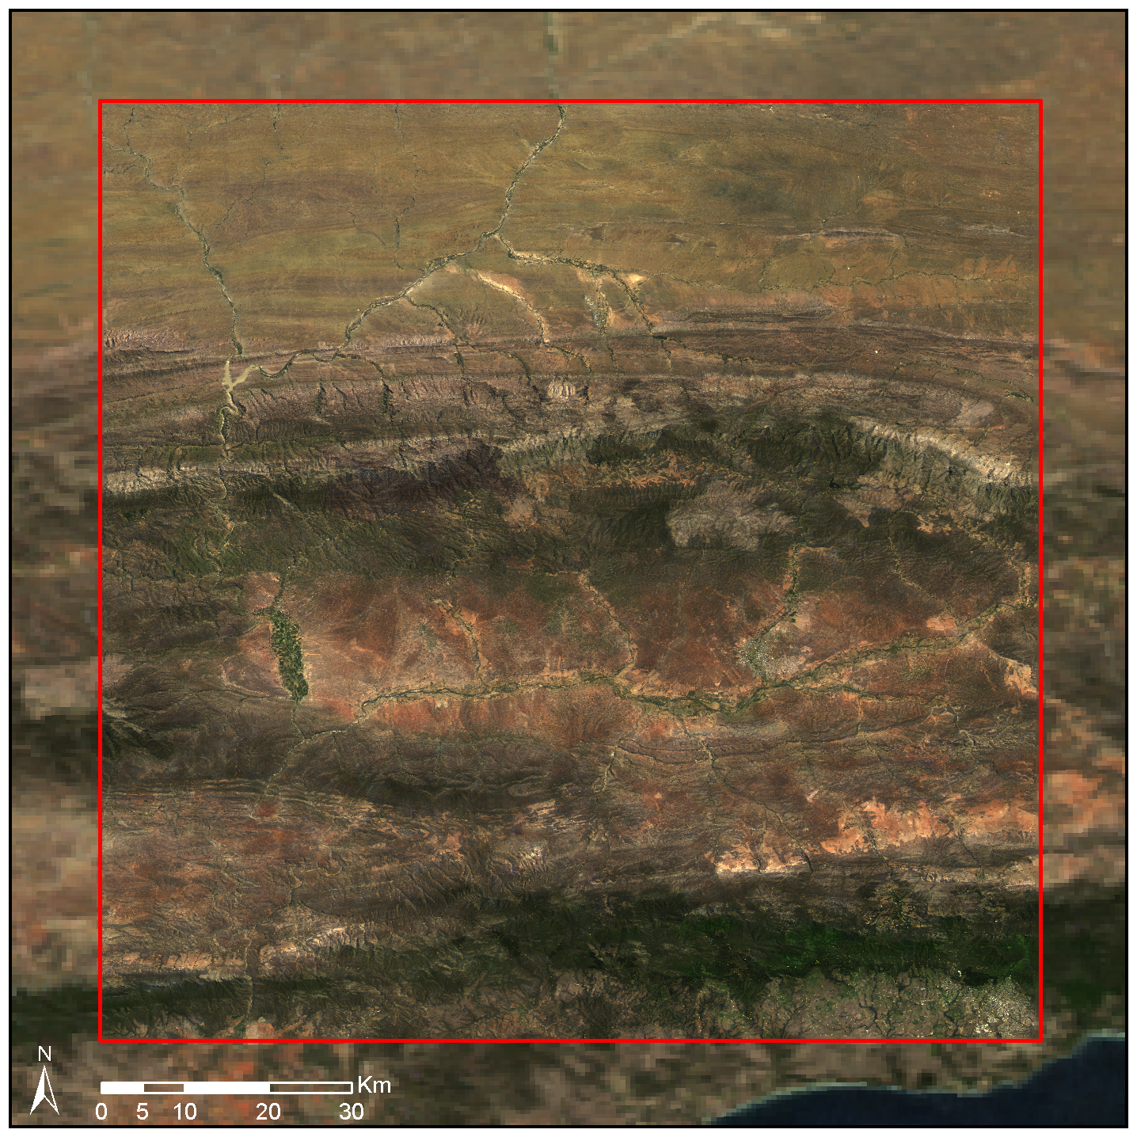

2.6

Figure 2.7a shows a close-up section of the DMC DN mosaic where a hot spot (i.e. a BRDF effect where sunlight is strongly reflected back into the camera) and seam lines between adjacent images are visible. Figure 2.7b demonstrates the successful removal of the hot spot and seam lines after correction with the surface reflectance extraction method.



|  |  |
| --- | --- |
| (a) | (b) |

Figure 2.7 Reduction of hot spot and seam lines. (a) Raw DN images showing hot spot and seam lines (b) Corrected surface reflectance image

### MODIS Comparison

Figure 2.8 shows scatter plots of the DMC DN and MODIS surface reflectance values with *R2* coefficients indicating correlation strength. Figure 2.9 shows similar scatter plots for the DMC and MODIS surface reflectance values. Differences in the MODIS and DMC surface reflectance values at MODIS resolution are due in part to the use of the cubic spline interpolation to upsample the **M** and **C** rasters from the MODIS to DMC resolution. The spline interpolation is non-invertible (i.e. downsampling the upsampled rasters does not produce the original **M** and **C** rasters but successively smooths the data at each application). As indicated by Figure 2.8 and Figure 2.9, the correlation of the DMC and MODIS values is significantly improved when using the extracted DMC surface reflectance rather than DN values. This improvement is not unexpected, as we are effectively comparing to the data we are fitting to. Nevertheless, this comparison serves as a general check on the validity of the method and as an indication of the effect of spline interpolation between the disparate MODIS and DMC resolutions. Mean absolute difference (MAD), root mean square (RMS), standard deviation and coefficient of determination statistics are given for the DMC and MODIS surface reflectance values in Table 2.1. Reflectance differences are greatest in the NIR band most likely due to the dissimilar MODIS and DMC RSR’s in this band.

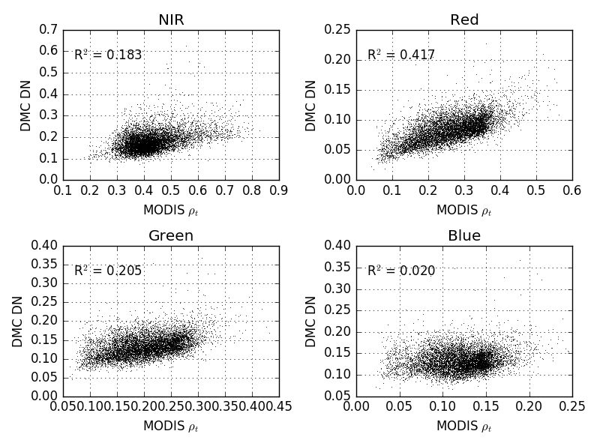

Figure 2.8 DMC DN mosaic and MODIS surface reflectance correlation

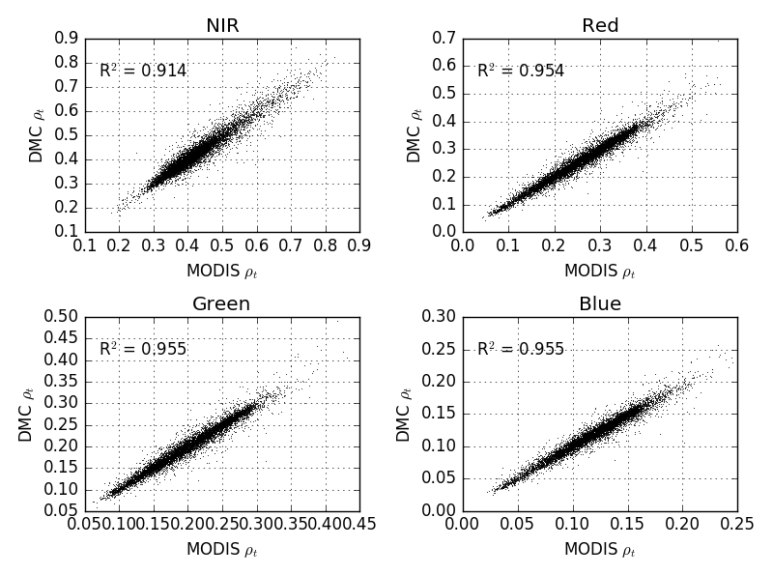

Figure 2.9 DMC surface reflectance mosaic and MODIS surface reflectance correlation

Table 2.1 Statistical comparison between MODIS and DMC surface reflectance images

|  |  |  |  |  |
| --- | --- | --- | --- | --- |
| Band(s) | Mean Abs. Diff. (%) | Root Mean Square (%) | Std. Dev. Diff. (%) | *R2* |
| Near infrared | 1.70 | 2.50 | 2.50 | 0.91 |
| Red | 1.18 | 1.75 | 1.75 | 0.95 |
| Green | 0.79 | 1.16 | 1.16 | 0.96 |
| Blue | 0.48 | 0.69 | 0.69 | 0.96 |
| **All** | **1.04** | **1.67** | **1.67** |  |

### SPOT 5 Comparison

Statistics for the reflectance difference between the corrected SPOT 5 image and the DMC surface reflectance mosaic are shown in Table 2.2. The reflectance differences represent not just errors in DMC surface reflectance but also contain contributions from spatial misalignment of pixels due to ortho-rectification differences and errors in the SPOT surface reflectance. A relatively low mean overall absolute reflectance difference of 4.18% indicates that the surface reflectance extraction method is effective. These reflectance differences compare well to figures reported by other aerial image correction methods. Collings et al. (2011) achieved RMS reflectance errors of 4-10% measured on placed targets of known reflectance for their aerial mosaic correction technique, and in the aerotriangulation approach of López et al. (2011), mean absolute reflectance differences of 3-5% were obtained on field measured test sites, distributed throughout their study area. Similarly to the MODIS comparison, the largest reflectance differences occur in the NIR band. Again, this is likely due to dissimilarities in the MODIS, DMC and SPOT sensor NIR RSR’s (see Figure 2.3 and Figure 2.11). Scatter plots of DMC DN and SPOT surface reflectance values are shown in Figure 2.12 and DMC surface reflectance and SPOT surface reflectance values are shown in Figure 2.13 with *R2* coefficients indicating correlation strength. The conversion to DMC surface reflectance provides a modest improvement in correlation between the DMC and SPOT values.

False colour CIR (colour-infrared) renderings of the DMC, SPOT and difference images are shown in Figure 2.10. The contrast stretched difference image shows that most discrepancies occur in the rugged mountainous areas that extend west to east in the northern section of the scene and in densely vegetated areas along river banks in the southern section of the scene. On closer inspection it was found that the disparities in the mountainous areas are mainly due to differing shadow effects which are likely caused by variations in the time of day when the images were captured (the aerial photographs were captured throughout the day, while the SPOT 5 image was captured at 8:29am). A particularly bright area is noticeable in the upper right corner of the difference image. This corresponds to an area of bare ground which is bright in both the DMC and MODIS images and likely corresponds to a BRDF correction failure. It is not possible to say if this failure is in the SPOT and or DMC corrections. The differences in the densely vegetated areas are attributed to the differences in the MODIS, DMC and SPOT sensor NIR RSR’s being amplified by the known high NIR reflectivity of vegetation.

|  |  |
| --- | --- |
|  |  |
| (a) | (b) |
|  | |
| (c) | |

Figure 2.10 DMC and SPOT surface reflectance comparison. (a) DMC surface reflectance mosaic masked to SPOT extent. (b) SPOT surface reflectance image. (c) Contrast stretched absolute difference image.

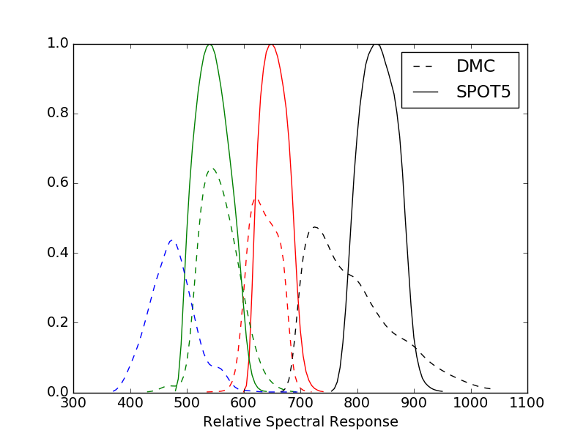

Figure 2.11 DMC and SPOT RSR’s

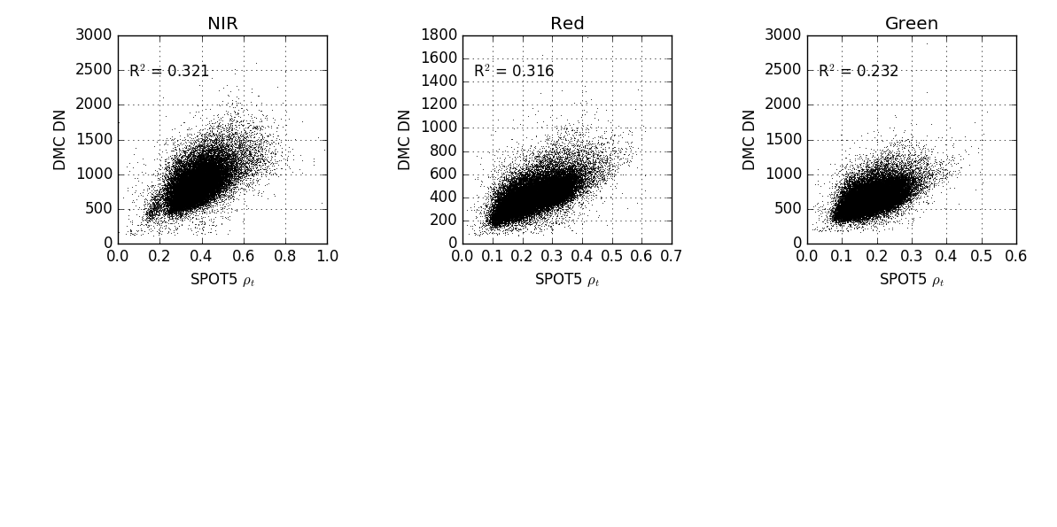

Figure 2.12 DMC DN mosaic and SPOT surface reflectance correlation

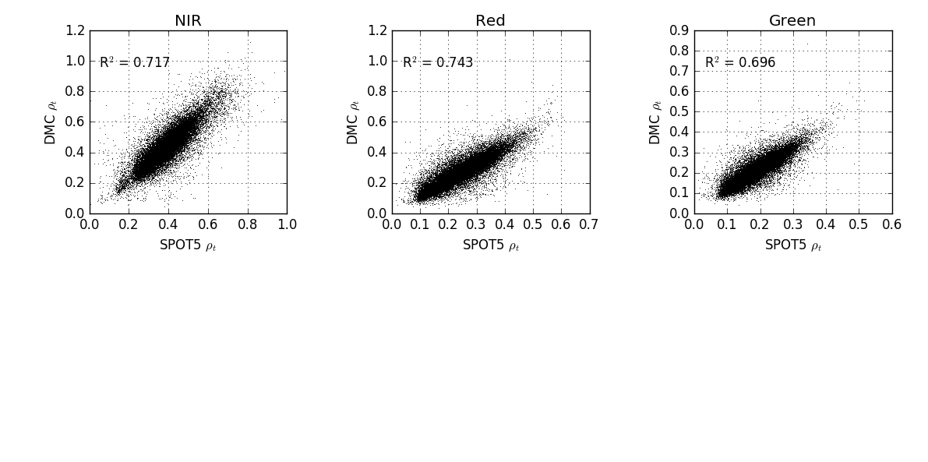

Figure 2.13 DMC surface reflectance mosaic and SPOT surface reflectance correlation



Table 2.2 Statistical comparison between SPOT 5 and DMC surface reflectance images

|  |  |  |  |  |
| --- | --- | --- | --- | --- |
| Band(s) | Mean Abs. Diff. (%) | Root Mean Square (%) | Std. Dev. Diff. (%) | *R2* |
| Near infrared | 5.88 | 7.72 | 6.18 | 0.717 |
| Red | 3.74 | 5.42 | 4.84 | 0.743 |
| Green | 2.93 | 4.29 | 3.65 | 0.696 |
| **All** | **4.18** | **5.99** | **5.11** |  |

## CONCLUSIONS

The surface reflectance extraction technique is simpler and computationally more efficient than existing aerial image correction approaches as it avoids the need for explicit BRDF and atmospheric correction as well as mosaic normalisation techniques to reduce seam lines. The spatially varying linear model allows for great flexibility in the BRDF characteristics that can be corrected for. It does however assume BRDF and atmospheric variations are gradual and can be captured by the coarser resolution of the reference image. Real BRDF can vary significantly over short distances where land cover is heterogeneous. We regard the assumption of slowly varying BRDF as a necessary limitation of the method, and it is one that is shared by others (López et al. 2011; Collings et al. 2011; Gehrke 2010; Chandelier & Martinoty 2009). The extracted surface reflectance can only be as accurate as the reference of course. According to the MODIS land team (2014), the NBAR data used in the case study is accurate to “well less than 5% albedo at the majority of the validation sites”. The method is also limited by the need for a reference image concurrent and spectrally similar to the aerial imagery. Such an image may not always be obtainable.

The proposed surface reflectance extraction method was applied to 2228 Intergraph DMC images covering an area 96 x 107km in size. A MODIS MCD43A4 image was used as the surface reflectance reference. The extracted DMC surface reflectance mosaic was free of visible seam lines and hot spots and matched the MODIS reference well. The DMC surface reflectance mosaic was also compared to a concurrent SPOT 5 image in order to establish the method efficacy at a spatial resolution closer to that of the DMC source resolution than the MODIS reference. The SPOT 5 image was corrected for atmospheric effects and converted to surface reflectance using the ATCOR-3 method. The mean absolute reflectance difference between the DMC mosaic and SPOT 5 image was 4.18%. This reflectance difference is considered supportive of the method’s accuracy and is similar to figures reported by Collings et al. (2011) and López et al. (2011) for more complex correction techniques. It is not just inaccuracies in the DMC surface reflectance, but spatial errors, temporal variation between images and errors in the SPOT surface reflectance that also contribute to this number.

The MODIS and DMC RSR’s are quite different, particularly in the near infrared region of the spectrum (see Figure 2.3). The surface reflectance extraction method assumes the effect of different sensor spectral responses is linear and will be contained by the model of Equation (2.8). This assumption was confirmed by a simulation of MODIS and DMC measurements for typical land cover spectra. The relatively higher (5.88%) NIR reflectance difference between the DMC mosaic and the SPOT 5 values, and discrepancies in vegetated areas, are likely due to the more exaggerated differences in NIR RSR’s between the MODIS, DMC and SPOT sensors.

While the results of the surface reflectance extraction technique were surprisingly good given the simplicity of the method, many aspects warrant further investigation. Evaluation of the efficacy of using different sensors to provide the reflectance reference is of interest. Local terrain effects are poorly represented at the MODIS resolution. It would be informative to test the method with a higher spatial resolution reference such as Landsat Operational Land Imager (OLI). The MISR instrument is also a promising alternative to MODIS and could also be evaluated as a reflectance reference. MISR RSR’s are a better match to those of the Intergraph DMC than the MODIS bands, and it is possible to obtain 275m reflectance products using MISR-HR (Verstraete et al. 2012). Strong emphasis is placed on accurate calibration of the MISR data as its instrument captures data at nine different angles which allows a more accurate modelling of the BRDF compared to the kernel based approach followed in the calibration of the MODIS data (Strahler et al. 1999).

In our case study, we assumed the parameter *C* in the model of Equation (2.5) was small enough to be ignored. Some haze was however visible in the blue band, casting doubt on this assumption. It would be interesting to investigate the effect of including *C* in the model. The effect of the size of the sliding window used to estimate *M* and *C* on accuracy was not investigated and should also be evaluated. One would expect a larger sliding window to reduce variance by averaging out local noise but decrease effective spatial resolution by smoothing the **M** and **C** rasters.



# FEATURE CLUSTERING AND RANKING

## ABSTRACT

High dimensional feature sets typically contain correlation amongst the features. Traditional feature selections approaches are prone to selection of sub-optimal features in these circumstances. A method for ranking features that is robust to correlation is presented. Average-linkage hierarchical clustering is used to group correlated features into clusters. Clusters are then ranked based on the performance of a naïve Bayes classifier on their constituent features. Individual features can then be selected from the best clusters. Problems of sub-optimality and instability of selected feature sets when using traditional methods are confirmed empirically on a vegetation mapping data set derived from aerial image pixel data. The presented method is applied to the same data. Stability of cluster rankings under different data samplings and selection criteria was shown to be significantly improved with the new method. Selected features produced good accuracies across a variety of classifiers.

## INTRODUCTION

As the number of features increases, the amount of data required to adequately represent class distributions in the increased feature space increases exponentially. This is known as the “curse of dimensionality” (Bishop 2003). For finite training samples, increasing the features beyond a certain point results in overtraining and a decrease in the classifier accuracy. This is called the “peaking phenomenon” (Jain, Duin & Mao 2000). As a rule of thumb, the number of training objects per class should be at least ten times the number of parameters required by classifier (Jain, Duin & Mao 2000). The peaking phenomenon makes it necessary to reduce the size of the feature set to a salient minimum. While Support Vector Machine (SVM) (Burges 1998) and random forest (Breiman 2001) classifiers are becoming popular, partly because of their lack of sensitivity to the peaking phenomenon, reducing the number of features is also beneficial from the perspective of measurement costs and feature computation time. The last point is particularly relevant in large scale remote sensing studies of Very High Resolution (VHR) imagery, due to the vast quantities of data requiring processing. A further motivation for reducing features to an informative minimum is the “ugly duckling theorem”, which implies that the more redundant features that are included, the less separable classes become (Jain, Duin & Mao 2000).

There are two basic approaches to feature set reduction: feature selection and feature extraction (Jain, Duin & Mao 2000). In feature extraction the feature set is mapped into a new feature space of reduced dimensionality. Various criteria can be used to define the dimensions of the new space such as separability and variance. A disadvantage of the feature extraction approach is that requires calculation of the full feature set and so does not reduce the amount of computation. Principal Components Analysis (PCA) is an example of a common feature extraction method.

Feature selection involves the selection of a subset of features from the original set according to some criterion of subset performance. The number of possible subsets increases combinatorially with the size of the feature set and it is seldom practical to evaluate all possible subsets (Jain, Duin & Mao 2000). A variety of search methods exist for reducing the portion of feature space searched. Of these, only the branch and bound method is globally optimal, the rest achieve reduced computation at the price of optimality. The complexity of the branch and bound method increases exponentially with the size of the feature set and so it is still computationally impractical for large feature sets (Jain, Duin & Mao 2000). The fastest and most straightforward search method is simply to rank features based on their individual performance and select the best *N*. The feature rankings produced as part of the classification and regression tree (CART) (Breiman et al. 1984) and random forest (Breiman 2001) classification algorithms fall under this category. CART is a method of ranking individual features based on the structure and parameters of a classification tree trained on the full feature set (Yu et al. 2006). The random forest is a classifier that can produce a feature ranking by permuting the values of a feature among the test objects and evaluating the reduction in classifier accuracy (Breiman 2001). Those features whose disturbance results in the highest reduction in accuracy are judged as being the most important.

More advanced search methods use greedy sequential approaches, such as forward selection and backward elimination. The forward selection (FS) approach starts with an empty feature set and proceeds in a number of steps where at each step, the feature from the remaining unselected features that improves an accuracy criterion the most is added to the model (Bishop 2003). The backward elimination (BE) method starts with the full set of features and removes one at each step. The feature whose removal produces the best accuracy according to some criterion is eliminated from the set at each step (Bishop 2003). BE is computationally costly and requires sufficient data to be able to train on the full feature set. The Sequential Floating Search methods SFFS and SBFS extend FS and BE by selecting and or eliminating a variable number of features at each step (Jain, Duin & Mao 2000). Greedy search methods are more likely to find the globally optimal feature set than the feature ranking approach as they are exploring more of the search space and are less inclined to select multiple correlated features.

A variety of selection criteria are used for comparing feature subsets such as measures of separability like the Mahalanobis distance or the accuracy of a specific classifier trained on the feature subset (Duin & Tax 2005). The results of feature selection are dependent on the selection criterion and search method used. A feature set that is optimal for one classifier is not necessarily optimal for another, so if using a classification criterion, one should ideally use the same classifier that will ultimately be used to label the selected features. The features selected are also dependent on the data used to evaluate the selection criterion.

The raw bands of aerial multi-spectral imagery tend to have significant spectral overlap (Intergraph 2008) and consequently are correlated with one another. As these correlated raw bands are the source data for all the derived features, and the derived feature definitions typically contain some redundancy (see Section 3.4), correlation amongst features is typical of aerial remote sensing data. In Bioinformatics, gene expression data is also recognised as typically containing a lot of correlation (Sahu & Mishra 2011; Yousef et al. 2007). A number of authors have noted difficulties in selecting features from high dimensional correlated sets. Tolosi & Lengauer (2011) show that the feature ranking produced by random forests, and other algorithms commonly used in bioinformatics, produce biased estimates of importance in the presence of correlation. A similar issue with random forests feature ranking is observed by Strobl et al. (2008). They note that less relevant features can be selected over more informative ones when there is correlation in the feature set and develop a technique to produce an unbiased feature importance measure. Yu & Liu (2004) and Yousef et al. (2007) confirm that feature redundancy can have a negative impact on the optimality of feature selection in general.

Correlation can be effectively dealt with using a feature extraction approach such as PCA but this requires computation of the full feature set. This is not practical in computationally demanding applications such as large area remote sensing of aerial imagery. A means of selecting good features in the presence of correlation was devised by Yousef et al. (2007). They use a k-means algorithm to produce a fixed number of clusters of correlated features. A backward elimination type greedy search is then conducted, eliminating whole clusters rather than individual features. The accuracy of a SVM is used as selection criterion. The clustering is then reapplied at each step. A similar method is described in Sahu & Mishra (2011), also using a k-means clustering to group correlated features. This is followed by a *t*-statistic or “Signal to Noise Ratio” (SNR) criterion to rank the clusters and select best features from each cluster. Yu & Liu (2004) use a non-linear correlation measure called symmetrical uncertainty to measure both feature relevance, by how well correlated features are with class labels, and feature redundancy, by how well correlated features are with each other. An innovative and efficient search method finds relevant features and removes redundant ones. Our method is similar in concept to those of Yousef et al. (2007), Sahu & Mishra (2011) and Tolosi & Lengauer (2011). It clusters correlated features and ranks the clusters using a simple classification accuracy measure. No prior knowledge of the number of clusters is needed however, and the clustering is only performed once.

## DATA AND GROUND TRUTH

A three class, multi-spectral pixel data set is used in this study. The pixel data originated from radiometrically corrected VHR aerial images, obtained from Chief Directorate: National Geospatial Information (NGI), a component of the South African Department of Rural Development and Land Reform. The images were captured with an Intergraph DMC camera which provides multi-spectral red, green, blue and near-infrared (NIR) bands at a 0.5m/pixel resolution. The data set was built as part of a broader vegetation mapping study being conducted in the Little Karoo, an arid region in South Africa (see Chapter 4 for details).

The three classes of interest are described in Table 3.1. The data ground truth labels were generated by visual inspection and manual delineation of objects belonging to the various classes in the images. Table 3.2 shows the total number polygons and pixels ground truthed for each class.

Table 3.1 Class descriptions

|  |  |
| --- | --- |
| Class Name | Description |
| Spekboom | *P. afra* |
| Tree | Any recognisable tree but especially the darker *Euclea* and *Pappea* trees commonly found intermingled in stands of *P. afra*. |
| Background | Bare ground, small shrubs, herbs and anything else not included in the first two classes. |

Table 3.2 Ground truth size

|  |  |  |
| --- | --- | --- |
| Class Name | Polygons | Pixels |
| Spekboom | 52 | 27260 |
| Tree | 64 | 3357 |
| Background | 44 | 182044 |
| **Total** | **160** | **212661** |

## FEATURES

The full feature set consisted of 46 features and was comprised of a typical combination of spectral features, vegetation indices and texture features. Similar features were used in Li et al. (2010) and Trias-Sanz, Stamon & Louchet (2008). The features can be separated into two broad categories: per-pixel and sliding window features. The per-pixel features are found with the spectral information from only that pixel, while the sliding window features are found from some statistic or function of the pixels inside a small local neighbourhood. The complete feature set and their labels are listed below in Table 3.3.

Table 3.3 Features

|  |  |  |
| --- | --- | --- |
| No. | Name | Description |
| 1 | R | Red |
| 2 | G | Green |
| 3 | B | Blue |
| 4 | NIR | Near-infrared |
| 5 | rN | Normalised R |
| 6 | gN | Normalised G |
| 7 | bN | Normalised B |
| 8 | nirN | Normalised NIR |
| 9 | NDVI | Normalised Difference Vegetation Index |
| 10 | RVI | Ratio Vegetation Index |
| 11-14 | tc1-4 | Tasselled cap components |
| 15-18 | pc1-4 | Principal components of raw bands |
| 19-22 | nc1-4 | Principal components of normalised bands |
| 23-26 | Entropy## | Sliding window entropy of pc1, RVI, NDVI and gN |
| 27-30 | Std## | Sliding window standard deviation of pc1, RVI, NDVI and gN |
| 31-34 | Mean## | Sliding window mean of pc1, RVI, NDVI and gN |
| 35-38 | Median## | Sliding window median of pc1, RVI, NDVI and gN |
| 39-42 | Skewness## | Sliding window skewness of pc1, RVI, NDVI and gN |
| 43-46 | Kurtosis## | Sliding window kurtosis of pc1, RVI, NDVI and gN |

Normalised colour features are defined by (Blauensteiner et al. 2006):

|  |  |  |
| --- | --- | --- |
| $$c_{i}^{n}=\frac{C_{i}}{\sum_{i=1}^{4}{C_{i}}}$$ |  | (3.1) |

Where $C_{i}$ are the raw R, G, B and NIR band values and $i$ is the band number. The denominator normalises for intensity and thus this space describes the relative contributions of the raw bands to overall intensity. The Ratio Vegetation Index (RVI) is given by

|  |  |  |
| --- | --- | --- |
| $$RVI=\frac{NIR}{R}$$ |  | (3.2) |

It has a range of zero to infinity and increases as the vegetation becomes denser and photosynthetically more active (Myneni et al. 1995). The well-known Normalised Difference Vegetation Index (NDVI) is defined as

|  |  |  |
| --- | --- | --- |
| $$NDVI=\frac{NIR-R}{NIR+R}$$ |  | (3.3) |

NDVI is limited to the range -1 to 1 and describes the same relationship as RVI but is easier to visualise and interpret due to its limited range. Both indices are invariant to intensity changes.

The tasselled cap transform of Kauth & Thomas (1976) was approximated for our problem using a principal component transform derived from the variance of the Spekboom class. This way the first component was aligned with Spekboom variation rather than wheat variation as in the original tasselled cap transform.

Entropy is a statistic that describes the amount of randomness in a variable. The entropy of the values in the image window $x$ is defined by

|  |  |  |  |
| --- | --- | --- | --- |
| $$E(x)=-\sum_{i}{h_{i}(x)}\log_{2}{h_{i}(x)}$$ |  |  | (3.4) |

Where $h_{i}(x)$ is the probability in the $i^{th}$ histogram bin of $x$. 256 bins were used in all cases.

In addition to the entropy, the median and the four central moment features (mean, standard deviation, skewness and kurtosis) of (Li et al. 2010) were included as sliding window features. The first principal component, RVI, NDVI and normalised green channel were all used as inputs to the sliding window feature set. A sliding window size of five pixels was used.

## METHOD

Our method is described as follows:

1. Perform average-linkage hierarchical clustering (Szekely & Rizzo 2005) of the feature set using the correlation coefficient as the dissimilarity metric.
2. Select a natural number of clusters containing high correlation by visual inspection of the dendrogram.
3. Rank each cluster’s importance by finding the accuracy of a naïve Bayes classifier trained on each individual feature and then finding the median of the feature accuracies in the cluster.
4. Select a single feature from each of the *N* clusters with best importance scores.

Hierarchical clustering provides a simple way of clustering the features that does not require prior knowledge of the number of clusters. It starts with each individual feature in its own cluster and proceeds in a number of steps where the pair of clusters that minimise a criterion are merged at each step. The dendrogram is graphical representation of this process. The average linkage criterion is the average dissimilarity over all pairs of objects in the two clusters.

Cluster stability and strength of correlation within each cluster are the key factors to consider when choosing the number of clusters and can be visually interpreted from the dendrogram. The naïve Bayes classifier was chosen to evaluate importance primarily because it makes no assumptions about the form of the class distributions and can thus provide a generic measure of separability. It is simple, fast and recognised as being accurate for a variety of problems (Hand & Yu 2001). The “naïve” assumption of feature independence is of no consequence when testing individual features. These justifications aside, our reasoning for the choice of dissimilarity metric, clustering algorithm and selection criterion is loose and other options could be also be effective.

The number of clusters, *N*, can be specified by the user based on the size of the training set or chosen using a grid search with the final classifier accuracy as performance measure. To avoid biased accuracy estimates, all classifier accuracy evaluation, for cluster ranking or selection of *N*, is done on unseen test data using a ten-fold cross validation (Bishop 2003). Major benefits of the cluster ranking method are its speed and that it allows hand-picking of the single features that represent each cluster. The flexibility to choose features allows the user to favour those features that are fastest to compute or perhaps to choose those features that are more readily understood. If these factors are not of importance, the highest individually ranked feature in each cluster can be chosen.

## RESULTS AND DISCUSSION

### Standard Feature Selection

We evaluated the sensitivity of standard feature selection approaches to different disturbances using the vegetation mapping data set. The size of the Background class was reduced to be the same as the Spekboom class by taking a random subsample. This was done to expedite computation times.

In the first experiment, a forward selection procedure with naïve Bayes classification accuracy as selection criterion was repeated on bootstrapped samples of the original data. The first six selected features are shown in Table 3.4 for five different data samplings. The first selected feature remains stable but the rest of the features are sensitive to the specific data set used to evaluate importance. This variation occurs in spite the fact that data contains more than sufficient samples to be representative of the real class distributions.

Table 3.4 Experiment 1: Forward selection results for different data sets

|  |  |  |  |  |  |  |
| --- | --- | --- | --- | --- | --- | --- |
| Sample Num. | Selected Features (Ordered by ranking) | | | | | |
| 1 | pc2 | tc4 | pc1 | SkewnessNDVI | StdRVI | rc3 |
| 2 | pc2 | rc3 | EntropyPc1 | KurtosisPc1 | SkewnessGn | KurtosisGn |
| 3 | pc2 | rc3 | MeanPc1 | StdGn | MedianRVI | KurtosisNDVI |
| 4 | pc2 | tc4 | EntropyPc1 | StdRVI | pc3 | MeanRVI |
| 5 | pc2 | rc3 | EntropyPc1 | KurtosisGn | SkewnessGn | SkewnessPc1 |

Next, the sensitivity to the selection criterion was evaluated by running a forward selection procedure with following criteria: inter–intra class distance, sum of Mahalanobis distances and the accuracies of naïve Bayes, decision tree and normal Bayes classifiers. Results in Table 3.5 show significant variation in the first six selected features, although certain features such as pc2, MeanPc1 and MedianPc1 are favoured by differing criteria.

Table 3.5 Experiment 2: Forward selection results for different selection criteria

|  |  |  |  |  |  |  |
| --- | --- | --- | --- | --- | --- | --- |
| Criterion | Selected Features (Ordered by ranking) | | | | | |
| Inter-intra | rN | NIR | rc3 | R | StdRVI | StdNDVI |
| Mahalanobis | MedianNDVI | rc3 | MeanPc1 | pc2 | pc4 | StdRVI |
| Naïve Bayes | pc2 | rc3 | MedianPc1 | SkewnessPc1 | KurtosisGn | KurtosisPc1 |
| Decision tree | pc2 | MedianGn | MedianPc1 | pc4 | MeanRVI | EntropyGn |
| Normal Bayes | pc2 | gN | MeanPc1 | rc3 | StdRVI | MeanNDVI |

Finally, common subset search methods were tested for their effect on selected features. All except the random forest used a naïve Bayes classification accuracy as selection criterion. It was not practical to evaluate the branch and bound method due to the computation time required. Variation in selected features is again significant and of such a degree that it is difficult to discern any consistency. Results are presented in Table 3.6.

Table 3.6 Experiment 3: Feature selection results for different search methods

|  |  |  |  |  |  |  |
| --- | --- | --- | --- | --- | --- | --- |
| Search Method | Selected Features (Ordered by ranking) | | | | | |
| FS | pc2 | rc3 | EntropyPc1 | SkewnessPc1 | KurtosisPc1 | SkewnessGn |
| BE | NIR | tc4 | rc1 | rc3 | EntropyPc1 | MedianNDVI |
| Individual ranking | pc2 | MeanNDVI | MedianNDVI | rN | NDVI | rc1 |
| Random forest | rN | StdRVI | tc4 | MedianPc1 | bN | MedianGn |

### Clustering and Ranking

The seemingly inexplicable variation in results of standard feature selection methods suggests that results are suboptimal. The likely cause of the instability is redundancy in our feature set. When doing feature selection with correlated features on overlapping problem, results can appear somewhat random as no particular feature makes a big impact and many are similar to each other. The effectiveness of the feature clustering and ranking method was tested on the vegetation mapping data. The dendrogram showing the clustering of the feature set is plotted in Figure 3.1. The line in red shows the correlation threshold value at which the feature clusters were extracted. This point was selected as a relatively stable point in the hierarchy and one where the correlation amongst features is strong.



Figure 3.1 Clustering of correlated features

The clusters were ranked using the naïve Bayes classification accuracy criterion. Table 3.7 lists the clusters ordered by their importance, with their component features. This table reveals a number of interesting properties of the features. Firstly, it is clear that there is a significant amount of correlation amongst the features in general. The correlation between raw R, G, B and NIR bands is surprisingly strong and these are all grouped into a single cluster. While the definitions of the nirN, NDVI and RVI features are quite different, they are all describing the same spectral property of vegetation, namely high absorption in the red band and high reflectance in the NIR band. This is confirmed by their collection in the same cluster. The mean sliding window feature, median sliding window feature and source feature operated on by those sliding windows are strongly correlated with each other as one would expected.

Table 3.7 Ranked clusters

|  |  |  |
| --- | --- | --- |
| Num. | Importance (%) | Features |
| 1 | 68.27 | rN, nirN, NDVI, RVI, tc2, pc2, rc1, MeanRVI, MedianRVI, MeanNDVI, MedianNDVI |
| 2 | 61.38 | R, G, B, NIR, tc1, pc1, MeanPc1, MedianPc1 |
| 3 | 60.41 | EntropyPc1 |
| 4 | 55.23 | gN, MeanGn, MedianGn |
| 5 | 54.52 | bN |
| 6 | 53.57 | rc2, rc4 |
| 7 | 50.57 | tc4, rc3 |
| 8 | 49.34 | pc4 |
| 9 | 47.93 | EntropyRVI, StdRVI, EntropyNDVI, StdNDVI |
| 10 | 43.96 | StdPc1 |
| 11 | 43.62 | EntropyGn, StdGn |
| 12 | 42.65 | tc3, pc3 |
| 13 | 41.29 | SkewnessRVI, SkewnessNDVI |
| 14 | 35.27 | SkewnessGn |
| 15 | 35.19 | KurtosisRVI, KurtosisNDVI |
| 16 | 35.03 | SkewnessPc1 |
| 17 | 34.86 | KurtosisGn |
| 18 | 33.86 | KurtosisPc1 |

The first two experiments of Section 3.6.1 were repeated with the feature clustering and ranking method, to compare its stability to that of standard methods. The effect of different bootstrap samples of the data set on the ranking of the top six clusters in shown in Table 3.8. The clusters are referred to by their numbers as shown in the first column of Table 3.7. Clusters 1 to 5 are consistently selected for all data samplings and cluster 6 is selected for all but one of the tests. This is a significant improvement in stability compared to the corresponding results from forward selection in Table 3.4.

Table 3.8 Experiment 4: Feature clustering and ranking results for different data sets

|  |  |  |  |  |  |  |
| --- | --- | --- | --- | --- | --- | --- |
| Sample Num. | Selected Clusters (Ordered by ranking) | | | | | |
| 1 | 1 | 2 | 3 | 4 | 5 | 7 |
| 2 | 1 | 2 | 3 | 5 | 4 | 6 |
| 3 | 1 | 2 | 3 | 4 | 5 | 6 |
| 4 | 1 | 2 | 3 | 4 | 5 | 6 |
| 5 | 1 | 2 | 3 | 4 | 5 | 6 |

Table 3.9 shows the resulting clusters for different selection criteria. Some variation in cluster ranking is seen for different criteria and this not unexpected as the criteria obviously view cluster importance differently. Results are nevertheless substantially more consistent than the equivalent experiment in Section 3.6.1 where no single feature was selected for all criteria. Here clusters 1, 2, 3, 5 and 6 are consistently part of the top six for the differing criteria.

Table 3.9 Experiment 5: Feature clustering and ranking results for different selection criteria

|  |  |  |  |  |  |  |  |
| --- | --- | --- | --- | --- | --- | --- | --- |
| Criterion | Selected Clusters (Ordered by ranking) | | | | | | |
| Inter-intra | | 1 | 5 | 6 | 3 | 2 | 9 |
| Mahalanobis | | 1 | 5 | 6 | 2 | 3 | 7 |
| Naïve Bayes | | 1 | 2 | 3 | 4 | 5 | 6 |
| Decision tree | | 1 | 2 | 3 | 4 | 5 | 7 |
| Normal Bayes | | 1 | 2 | 6 | 3 | 5 | 4 |

We selected the features NDVI, pc1, EntropyPc1, gN, bN and rc2 from the top six clusters of Table 3.7. Selection of sliding window features was avoided where possible as they are computationally more demanding than the per-pixel features. There is only one sliding window feature, EntropyPc1 in our final selection. This makes for a very significant improvement in computation time over the full feature set. Decision tree, random forest, Support Vector Machine (SVM) and K-Nearest-Neighbour (KNN) classifiers were trained and tested on the selected features using a ten-fold cross validation. Results are given in Table 3.10. Similarly good performances are obtained across all classifiers, confirming the value of the selected features.

Table 3.10 Classifier performance comparison

|  |  |  |  |  |
| --- | --- | --- | --- | --- |
| Classifier | 3 Class Error (%) | CA (Bg / Sb / Tr)a | PA (Bg / Sb / Tr)a | Kappa |
| Decision Tree | 9.46 | 97.64 / 98.10 / 46.86 | 91.22 / 94.49 / 85.91 | 0.87 |
| Random Forest | 9.16 | 98.72 / 97.51 / 47.97 | 89.66 / 96.96 / 85.91 | 0.88 |
| KNN | 10.45 | 97.27 / 97.49 / 80.27 | 97.08 / 98.82 / 72.74 | 0.94 |
| SVM | 10.58 | 97.17 / 95.33 / 79.73 | 94.44 / 98.69 / 75.12 | 0.92 |

a CA = Consumer’s Accuracy (%), PA = Producer’s Accuracy (%), Bg = Background, Sb = Spekboom, Tr = Tree

## CONCLUSIONS

Correlation amongst features was identified as a source of instability and inaccuracy in feature selection. A method for ranking correlated clusters of features was presented. Using hierarchical clustering, a natural number of clusters can be selected by observing the stability of correlation relationships in the data using a dendrogram. Clusters are then ranked using an importance measure, calculated as the median of the accuracy of a naïve Bayes classifier trained on each individual feature in the cluster. By selecting individual features from the best clusters, a set of informative features is found while simultaneously removing correlation from the data. The ability to hand-pick features is beneficial as it allows other factors to be included in determining the optimal feature set such as speed of computation and physical interpretability.

Experiments were conducted on a three class vegetation mapping data set consisting of 46 features derived from VHR multi-spectral image pixel data. There was a large amount of correlation amongst the features. It was shown that features selected using a standard forward selection approach were sensitive to different data samplings and selection criteria. Various standard search methods were also found to select vastly different groups of features. Using feature clustering and ranking, selected features were substantially more consistent under different data samplings and different selection criteria. The selected features also produced good accuracies on a variety of classifiers.

A possible weakness in the presented method is the formulation of the importance measure. The clusters are evaluated in isolation which makes selection susceptible to sub-optimality as the best individual clusters are not necessarily the best collectively (Cover 1974). Ideally the importance of clusters should be evaluated in the context of other clusters so that the effect of informative relationships is incorporated into the ranking. One option would be to follow a backward elimination type approach similar to Yousef et al. (2007). Alternatively, using the random forest concept of feature importance, we suggest the following as a simple and efficient approach that does not require training on the complete set of features:

1. Find the first principal component of each cluster’s features. Use this as a representative feature for that cluster.
2. Train a naïve Bayes classifier on the full set of representative features and find its accuracy.
3. For each cluster, permute that cluster’s representative feature amongst the samples in the test set and find the accuracy of the naïve Bayes classifier on the disturbed set.
4. The decrease in accuracy between steps 2 and 3 becomes the importance measure for that cluster.

Another aspect of our method that could benefit from further investigation is the correlation coefficient dissimilarity metric. While non-linear relationships between features were captured by this linear measure in our experiments (for example the relationship between RVI and NDVI), this will not always be the case. It would be preferable to use a metric that can describe non-linear correlation, such as the symmetrical uncertainty used in Yu & Liu (2004).

# VERY HIGH RESOLUTION MAPPING OF *PORTULACARIA AFRA* CANOPY COVER

## ABSTRACT

Very high resolution canopy cover maps of *P. afra* are required to assist with restoration of degraded habitat in the Little Karoo. Variations in habitat and level of degradation, in addition to radiometric variations in the imagery, make this a challenging problem. High resolution remote sensing of vegetation over large spatial extents has not received much attention, especially in arid areas. Here we present a per-pixel classification approach for canopy cover mapping of *P. afra*. Multi-spectral 0.5m resolution aerial imagery was obtained from Chief Directorate: National Geospatial Information and radiometrically corrected using a cross calibration technique. Ground truth was produced by selecting and hand labelling polygons in the imagery. A feature clustering and ranking procedure that is robust to correlation amongst features was applied to select an informative feature subset from a typical set of spectral, textural and vegetation index features. Support Vector Machine (SVM), random forest, decision tree, K-Nearest Neighbour (KNN) and Bayes normal classifiers were evaluated against both the hand labelled image ground truth and canopy cover ground truth acquired at 20 field sites. All classifiers except the Bayes normal classifier performed similarly well. The decision tree produced the best results on the field ground truth and was chosen as the final classifier. It produced a mean absolute canopy cover error of 5.85% with a standard deviation of 4.65% on the field ground truth. These results compare favourably with similar studies. Visual inspection of the canopy cover map showed good overall accuracy with some sensitivity to habitat variation.

## INTRODUCTION

*Portulacaria afra* (Spekboom) is an evergreen succulent tree growing to 2.5m, with a dense canopy of small fleshy leaves. It occurs in the Subtropical Thicket biome in the semi-arid Eastern Cape and Little Karoo regions in South Africa (Vlok, Cowling & Wolf 2005). “The Subtropical Thicket habitat types are most easily recognized by the occurrence of woody trees, spinescent shrubs and a relative abundance of succulents. When occurring as solid stands the vegetation can form impenetrable dense thickets, but this is uncommon in the Little Karoo. In most of the area the Subtropical Thicket vegetation occurs as discrete bush-clumps, usually in a matrix of Succulent Karoo vegetation” (Vlok, Cowling & Wolf 2005: 41). While *P. afra* is tolerant of browsing by indigenous herbivores, it is highly susceptible to over browsing by goats (Marais, Cowling & Powell 2009; Sigwela et al. 2009; Mills et al. 2007; Mills et al. 2005). Poorly managed goat grazing has transformed thicket over much of its range into sparsely scattered thicket clumps, isolated trees and a covering of herbs (Mills et al. 2005).

There is considerable interest in actively restoring degraded thicket habitat. *P. afra* is unusually effective at storing carbon for an arid region. Its carbon storage capacity competes with that of mesic forests (Mills et al. 2005). Subtropical Thicket provides an important source of food for many herbivores, including domesticated livestock (Thompson et al. 2009; Vlok, Cowling & Wolf 2005). Re-establishment of *P. afra* in degraded areas will reduce erosion, reduce flood severity and improve water quality (Van Luijk et al. 2013; Mills & Cowling 2006). It is also attractive from an employment perspective; potentially creating thousands of jobs in impoverished areas, if implemented on a large scale.

The dense canopy of *P. afra* facilitates an accumulation of soil organic matter which in turn significantly improves the water-holding capacity and fertility of the soil (Adie & Yeaton 2013; Mills & Cowling 2010; Lechmere-Oertel et al. 2008; Mills & Fey 2004). The provision of shade, improved soil quality and moisture retention, creates a favourable environment for other plants to germinate (Adie & Yeaton 2013; Mills & Cowling 2010). It has been observed that over a period of 40 to 50 years, woody canopy and other species re-establish in *P. afra* restoration areas to a degree that restored thicket is compositionally comparable to intact thicket (Van der Vyver et al. 2013).

*P. afra* canopy cover maps are required to assist in the restoration process. Canopy cover measurements are currently being done by visual inspection in the field. There is a need for greater accuracy and repeatability than is possible with this technique. One of the factors informing the identification of candidate restoration areas is the level of degradation. This can be estimated from the existing canopy cover and measures of intact canopy cover in a similar habitat to the restoration area. Measures of intact canopy cover also provide a guide as to an appropriate planting density. Restoration progress can be monitored by updating the canopy cover map over time. Canopy cover represents a first step towards being able to remotely sense biomass (Eisfelder, Kuenzer & Dech 2012; Suganuma et al. 2006; Ludwig, Reynolds & Whitson 1975), which would assist in the carbon accounting required for trading credits on the international market (Mills et al. 2010). It would also allow the estimation of expected carbon storage resulting from restoration which would provide an indication of the economic feasibility of restoration. A canopy cover map would also be a useful tool for deepening the present understanding of the Subtropical Thicket biome.

Thompson et al. (2009) conducted a degradation mapping study in the Little Karoo. A detailed 1:50000 vegetation map of the Little Karoo developed by Vlok, Cowling & Wolf (2005), was used to delineate different habitats so they could be treated separately. The degradation levels of Subtropical Thicket were derived by thresholding MODIS NDVI data. North and south facing slopes were treated separately to account for the different densities of *P. afra* in these topographies. To exploit the relative greenness of *P. afra* compared to the background vegetation, data from the September growing season was used for the thresholding. This NDVI data was averaged over two years. The study was successful at estimating intact, moderate and severe degradation levels of *P. afra* thicket at the MODIS resolution of 250m.

Currently, there is an initiative to involve private land-owners in restoration in order to broaden its impact (Curran et al. 2012; Mills et al. 2010). Maps at a pixel resolution of 1.5m or smaller are required to provide sufficient spatial detail for working with expected stand sizes of the order of 50 hectares. To achieve sufficient accuracy for carbon storage estimations, it will be necessary to estimate canopy cover in finer detail than the three levels of degradation used in Thompson et al. (2009). Our work aims to meet these requirements by accurately mapping *P. afra* canopy cover at a spatial resolution of 0.5m.

## STUDY AREA

The Little Karoo as defined in Vlok, Cowling & Wolf (2005), is a semi-arid region of great biodiversity lying between two mountain ranges. Three biomes considered to be biodiversity hotspots of global significance intersect in the Little Karoo (Thompson et al. 2009). 54 habitat types were identified by Vlok, Cowling & Wolf (2005) in their vegetation map, of which ten support *P. afra*. The Subtropical Thicket biome makes up 35.3% of the Little Karoo which has a total area of 2 343 900 ha (Vlok, Cowling & Wolf 2005). It was found that 89.3% of the *P. afra* thicket was degraded to some extent in an area comprising roughly half of the Little Karoo (Thompson et al. 2009). The Little Karoo is an interesting study area because it contains a significant portion of *P. afra* suited and degraded habitat and has been targeted for restoration. A representative portion was chosen as the study area, as shown in Figure 4.1. This area includes examples of all the different biomes and nine of the ten habitat types supporting *P. afra* as defined by Vlok, Cowling & Wolf (2005). Figure 4.2 shows a study area map of the different habitats supporting *P. afra*.



Figure 4.1 Little Karoo study area

## DATA AND GROUND TRUTHING

We acquired VHR aerial imagery of the study area from Chief Directorate: National Geo-spatial Information (NGI), a component of the South African Department of Rural Development and Land Reform. The images are captured at a 0.5m/pixel resolution with an Intergraph DMC camera which provides multi-spectral red, green, blue and near-infrared (NIR) bands. The imagery for our study area consists of 2228 images acquired over multiple days from 22 January to 8 February 2010. While the imagery provided by NGI is orthorectified, it has no radiometric corrections applied to it. The NGI imagery contains significant variations due to BRDF effects, atmospheric effects and viewing geometry which make it poorly suited to quantitative remote sensing techniques. We calibrated the imagery to surface reflectance, correcting for coarse scale atmospheric and BRDF effects, using the method described in Chapter 2. Calibration to an absolute physical quantity such as reflectance is beneficial as this is an invariant property of the surface. It also allows the data to be used in physical models and fused or otherwise used in combination with other calibrated data sources and used in multi-temporal studies. Radiometric calibration is important for our study as it allows accurate snapshot mapping over a large spatial area as well as provides the possibility of repeating the canopy cover mapping over time to evaluate restoration progress.

Canopy cover ground truth was acquired in the field at 20 different sites, each of roughly one hectare. A botanist with significant experience in the area provided expertise in the selection of sites to encompass variation in geology, habitat and level of degradation. Boundary polygons, were recorded for each site by walking the perimeter with a DGPS device. These were post-processed to provide sub one meter accuracy. Estimates of canopy cover inside the polygons were established visually and reference photos captured. The locations of the ground truth sites and their corresponding area names are shown in Figure 4.2. Details of the mosaic vegetation, geology and measured canopy cover for each site are given in Table 4.1. A three level degradation measure, as used in (Thompson et al. 2005), is reported for each site. The canopy cover measures were made in the field as a range between minimum and maximum values, spanning at most ten percent. The midpoint between these minimum and maximum values is reported in Table 4.1. This data set is referred to as the “field ground truth”. Figure 4.3 shows an example of a ground truth polygon on a background of the NGI imagery, rendered in RGB.

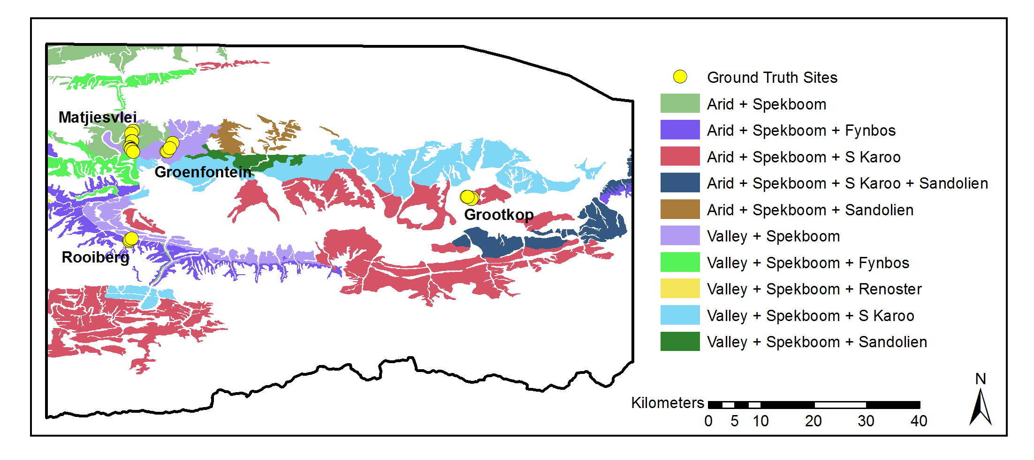

|  |  |
| --- | --- |
| Figure 4.2 Study area *P. afra* habitats and field ground truth sites | Source: (Vlok, Cowling & Wolf 2005) |

Table 4.1 Field ground truth site information

|  |  |  |  |  |  |
| --- | --- | --- | --- | --- | --- |
| Area | Number | Geology | Mosaic | Degradation | Cover (%) |
| Matjiesvlei | 1a | Shale | Arid Spekboom | Pristine | 6.0 |
|  | 1b |  |  | Pristine | 22.5 |
|  | 2 |  |  | Pristine | 70.0 |
|  | 3 |  |  | Pristine | 85.0 |
|  | 4 |  |  | Pristine | 65.0 |
|  | 5 |  |  | Pristine | 37.5 |
|  | 6 |  |  | Pristine | 17.5 |
|  | 7 |  |  | Pristine | 15.0 |
|  | 8 |  |  | Pristine | 2.0 |
| Groenfontein | 1 | Shale | Arid Spekboom | Severe | 0.0 |
|  | 2 |  |  | Severe | 4.0 |
|  | 3 |  |  | Severe | 10.0 |
|  | 4 |  |  | Moderate | 25.0 |
| Grootkop | 1 | Enon Conglomerate | Succulent Karoo | Pristine | 22.5 |
|  | 2 |  |  | Severe | 0.5 |
|  | 3 |  |  | Moderate | 42.5 |
|  | 4 |  |  | Pristine | 77.5 |
| Rooiberg | 1 | Sandstone | Fynbos | Pristine | 20.0 |
|  | 2 |  |  | Moderate | 11.0 |
|  | 3 |  |  | Severe | 0.0 |

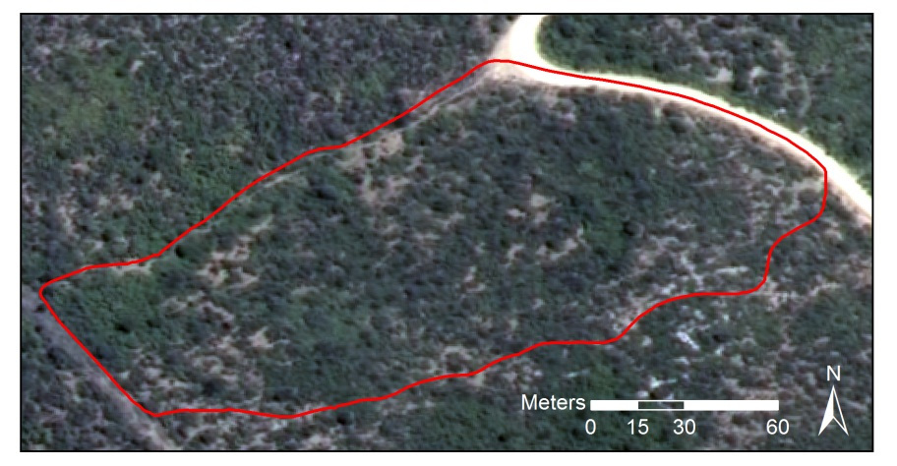

Figure 4.3 Matjiesvlei2 ground truth site

Table 4.2 Class descriptions

|  |  |
| --- | --- |
| Class Name | Description |
| Spekboom | *P. afra* |
| Tree | Any recognisable tree but especially the darker *Euclea* and *Pappea* trees commonly found intermingled in stands of *P. afra*. |
| Background | Bare ground, small shrubs, herbs and anything else not included in the first two classes. |

We adopted a labelling scheme of three classes as described in Table 4.2. While canopy cover mapping is in essence a two class problem (*P. afra* and everything else), the addition of the third Tree class provided a number of advantages in designing the classifier. By merging multiple classes into a single class, the ability to adjust the priors of individual merged classes is lost. The class priors, or “weights”, control the relative emphasis the classifier places on identifying each class correctly (Mingguo, Qianguo & Mingzhou 2009). The differentiation of *P. afra* from trees is a particularly challenging part of the problem due to their spectral and textural similarity. Thus the addition of the Tree class is useful, as it allows control over the classification accuracy of trees relative to the other classes. The descriptive power or complexity of the classifier is also improved by including the extra class, given sufficient training data. Rather than modelling only two classes, the classifier is now modelling three classes which improves its ability to approximate complex decision boundaries, especially in the vicinity of the problematic Tree - Spekboom overlap. It can be seen as a kind of classifier combination where multi-modal data is handled with a combination of per-mode classifiers (Jain, Duin & Mao 2000). Finally, the additional class provides greater diagnostic detail on the performance of the classifier. For instance, in the three class confusion matrix, it can be seen if Spekboom is primarily being misclassified as Background or as Tree. This diagnostic information is useful in adjusting classifier parameters to improve performance.

Classifier training data was obtained by visual discrimination and hand labelling of images. RGB and CIR images were used side by side in this exercise. Objects belonging to the various classes were delineated with polygons as shown in Figure 4.4. Only objects where there was a reasonable degree of confidence of class membership were included in the ground truth. Despite this, it is unavoidable that the ground truth contains some inaccuracies as it is not always easy to visually distinguish between the different classes. Areas were selected to encompass variability in habitat and level of degradation. This ground truth was however limited to the four images containing the field ground truth of Table 4.1. The total number polygons and pixels ground truthed for each class is shown in Table 4.3. This data set is referred to as the “image ground truth”.



Figure 4.4 Hand labelled ground truth

Table 4.3 Image ground truth size

|  |  |  |
| --- | --- | --- |
| Class Name | Polygons | Pixels |
| Spekboom | 52 | 27260 |
| Tree | 64 | 3357 |
| Background | 44 | 182044 |
| **Total** | **160** | **212661** |

## METHODOLOGY

We followed a statistical pattern recognition approach to classify *P. afra* canopy. Our pixel size of 0.5m, combined with the tendency of *P. afra* to grow in continuous stands meant that there was little spectral mixing and pixels covering *P. afra* were relatively pure. This supported a hard per-pixel classification approach as opposed to a soft classification (Xu et al. 2005) or regression type approach that is often used in biomass estimation (Eisfelder, Kuenzer & Dech 2012; Lu 2006). The fractional canopy cover was then determined as the portion of pixels classified as *P. afra* over an area of interest. Object based approaches to image classification, where homogenous objects are first segmented and then classified as a whole, are receiving a lot of attention. These approaches are often favoured for VHR imagery because they are potentially able to better exploit the additional spatial information and deal with unwanted variation when compared to the more traditional per-pixel approach (Yu et al. 2006; Carleer, Debeir & Wolff 2005). The segmentation problem is however recognised as being poorly posed, requiring manual adjustment of parameters and being difficult to solve robustly (Baraldi et al. 2010). We followed a pixel based approach as this gave us adequate accuracy and avoided the complexities and computation time associated with segmentation. Some vegetation has distinctive phenological variations which can be a useful source of information in distinguishing different species or measuring characteristics of a habitat such as degradation (Thompson et al. 2009). We were limited to a snapshot approach as there was only one set of aerial imagery available from NGI at the time of writing.

## FEATURES

*P. afra* has a characteristic lime green colour is evergreen. Somewhat fortuitously, the NGI imagery was captured in January, which is in the Little Karoo’s dry season. This helped contrast the evergreen *P. afra* against the relatively drier background vegetation. In a relatively undisturbed state, it grows in clumps consisting of many shrubs, interspersed with occasional trees such as *Pappea* and *Euclea*. A set of 46 features that would aid in describing these visual characteristics of *P. afra* were evaluated. The set included a fairly typical combination of spectral features, vegetation indices and texture features. Similar features have been used in Li et al. (2010) and Trias-Sanz, Stamon & Louchet (2008).

The features we used can be separated into two broad categories: per-pixel and sliding window features. The per-pixel features are found with the spectral information from only that pixel, while the sliding window features are found from some statistic or function of the pixels inside a small local neighbourhood. The sliding window features describe some aspect of the relationship between a small neighbourhood of pixels. While the spectral resolution of the VHR imagery is poor, the spatial resolution allows description of vegetation structure and spatial patterns that is not possible with lower resolution satellite imagery. Texture is recognised as an important feature in biomass estimation in complex habitats (Singh, Malhi & Bhagwat 2014; Lu 2006). The sliding window features were included to try and exploit this source of information in distinguishing our classes. We could not include common texture features such as statistics of the Gray Level Co-occurrence Matrix (GLCM) or the occurrence histograms of Local Binary Patterns (LBP). To be representative, these texture features need to be calculated from a greater number of pixels than is practical with a sliding window. Typically they are evaluated per region and thus require an object based approach.

The colour of an object is defined by the shape of its reflectance spectrum while the intensity is defined by the spectral amplitude. The dimensions of the raw RGB colour space are coupled with intensity. Colour is captured by the relative amounts of the raw colour bands rather than their absolute values. Normalised colour features are defined by (Blauensteiner et al. 2006):

|  |  |  |  |  |
| --- | --- | --- | --- | --- |
| $$c_{i}^{n}=\frac{C_{i}}{\sum_{i=1}^{4}{C_{i}}}$$ |  |  |  | (4.1) |

Where $C_{i}$ are the raw R, G, B and NIR band values and $i$ is the band number. The denominator normalises for intensity and thus this space describes the relative contributions of the raw bands to overall intensity. While we have calibrated the imagery to surface reflectance, this was done at a coarse spatial scale and variations in intensity remain at a fine resolution. This normalised colour space will assist in further removing intensity variations not removed by the calibration. The HSV space serves a similar purpose, but was not used as the H (hue) dimension is angular and thus has a discontinuity between 0o and 360o. This is problematic for distance measures or modelling of class distributions in pattern recognition.

Green, living vegetation absorbs light in the Photosynthetically Active Radiation (PAR) region of the spectrum which corresponds to the red band. There is a sharp transition from absorption to reflection around 700nm (Gates 1980). Vegetation is highly reflective in the near infra-red band as the energy in these wavelengths is insufficient for photosynthesis and potentially harmful due to its heating effects. Various vegetation indices exploit these spectral properties. The Ratio Vegetation Index (RVI) is given by:

|  |  |  |
| --- | --- | --- |
| $$RVI=\frac{NIR}{R}$$ |  | (4.2) |

It has a range of zero to infinity and increases as the vegetation becomes denser and photosynthetically more active (Myneni et al. 1995). The well-known Normalised Difference Vegetation Index (NDVI) is defined as

|  |  |  |
| --- | --- | --- |
| $$NDVI=\frac{NIR-R}{NIR+R}$$ |  | (4.3) |

NDVI is limited to the range -1 to 1 and contains the same information as RVI but is easier to visualise and interpret due to its limited range. Both indices are invariant to intensity changes.

The tasselled cap transform is a linear transform of the raw band feature space to a new orthogonal co-ordinate system, similar to a principal component transform. It was designed for agricultural wheat classification and was intended to reduce variability in soil and wheat classes by removing variation due to topography, sun angle and wheat growth stage (Kauth & Thomas 1976). The tasselled cap transform was approximated for our problem using a principal component transform derived from the variance of the Spekboom class. This way the first component was aligned with Spekboom variation rather than wheat variation as in the original tasselled cap transform. As it is simply a rotation of the raw band space, its usefulness is as a dimensionality reduction technique similar to PCA, rather than as an extractor of novel features. The principal components of the normalised colours of Equation (4.1) were also included to capture texture arising from colour variation.

Entropy is a statistic that describes the amount of randomness in a variable. It was included in our feature set as a texture feature to describe complexity in the local neighbourhood of a sliding window. The entropy of the values in the image window $x$ is defined by (Trias-Sanz, Stamon & Louchet 2008):

|  |  |  |  |
| --- | --- | --- | --- |
| $$E(x)=-\sum_{i}{h_{i}(x)}\log_{2}{h_{i}(x)}$$ |  |  | (4.4) |

Where $h_{i}(x)$ is the probability in the $i^{th}$ histogram bin of $x$. 256 bins were used in all cases.

In addition to the entropy, the median and the four central moment features (mean, standard deviation, skewness and kurtosis) of Li et al. (2010) were included as sliding window features. The first principal component, RVI, NDVI and normalised green channel were all used as inputs to the sliding window feature set. The complete feature set and their labels are listed below in Table 4.4.

Table 4.4 Features

|  |  |  |
| --- | --- | --- |
| No. | Name | Description |
| 1 | R | Red |
| 2 | G | Green |
| 3 | B | Blue |
| 4 | NIR | Near-infrared |
| 5 | rN | Normalised R |
| 6 | gN | Normalised G |
| 7 | bN | Normalised B |
| 8 | nirN | Normalised NIR |
| 9 | NDVI | Normalised Difference Vegetation Index |
| 10 | RVI | Ratio Vegetation Index |
| 11-14 | tc1-4 | Tasselled cap components |
| 15-18 | pc1-4 | Principal components of raw bands |
| 19-22 | nc1-4 | Principal components of normalised bands |
| 23-26 | Entropy## | Sliding window entropy of pc1, RVI, NDVI and gN |
| 27-30 | Std## | Sliding window standard deviation of pc1, RVI, NDVI and gN |
| 31-34 | Mean## | Sliding window mean of pc1, RVI, NDVI and gN |
| 35-38 | Median## | Sliding window median of pc1, RVI, NDVI and gN |
| 39-42 | Skewness## | Sliding window skewness of pc1, RVI, NDVI and gN |
| 43-46 | Kurtosis## | Sliding window kurtosis of pc1, RVI, NDVI and gN |

## FEATURE SELECTION

The raw bands of the NGI imagery have significant spectral overlap (Intergraph 2008) and consequently are highly correlated with one another. This is a common feature of aerial multi-spectral sensors. As these correlated raw bands are the source data for all the derived features, and the derived feature definitions contain some redundancy, correlation amongst features is likely present in our data. A number of authors have noted that feature redundancy can cause inconsistencies and sub-optimality in selected features when using standard approaches (Sahu & Mishra 2011; Tolosi & Lengauer 2011; Strobl et al. 2008; Yousef et al. 2007). Correlation can be effectively dealt with using a feature extraction approach such as PCA but this requires computation of the full feature set. This is not practical in computationally demanding applications such as ours.

We devised a feature ranking method, called feature clustering and ranking, which is robust to correlation. It is described in more detail in Chapter 3. It clusters correlated features and ranks the clusters using a simple classification accuracy measure and is similar in concept to those of Yousef et al. (2007), Sahu & Mishra (2011) and Tolosi & Lengauer (2011). No prior knowledge of the number of clusters is needed however, and the clustering is only performed once.

Feature clustering and ranking is described as follows:

1. Perform average-linkage hierarchical clustering (Szekely & Rizzo 2005) of the feature set using the correlation coefficient as the dissimilarity metric.
2. Select a natural number of clusters containing high correlation by visual inspection of the dendrogram.
3. Rank each cluster’s importance by finding the accuracy of a naïve Bayes classifier trained on each individual feature and then finding the median of the feature accuracies in the cluster.
4. Select a single feature from each of the *N* clusters with the best importance scores.

The number of clusters, *N*, can be specified by the user based on the size of the training set or chosen using a grid search with the final classifier accuracy as performance measure. To avoid biased accuracy estimates, all classifier accuracy evaluation, for cluster ranking or selection of *N*, is done on unseen test data using a ten fold cross validation (Bishop 2003). Major benefits of the cluster ranking method are its speed and that it allows hand-picking of the single features that represent each cluster. The flexibility to choose features allows the user to favour those features that are fastest to compute or perhaps to choose those features that are more readily understood.

## CLASSIFICATION

The canopy cover mapping accuracies of decision tree, random forest, Support Vector Machine (SVM), Bayes normal and K-Nearest-Neighbour (KNN) classifiers were evaluated. Some background on these classifiers and the basic approach adopted for canopy cover mapping is given here.

A decision tree is a tree of binary decision nodes based on thresholds of different features. Data is recursively split at each branch node until a terminal is reached representing a class label (Breiman et al. 1984). Training is performed by a greedy procedure which iteratively adds nodes and selects features producing the best split for each node. Criteria used for choosing the best feature at each node include the information content, node purity and Fisher’s criterion (Jain, Duin & Mao 2000). Overtraining is a concern and trees can be pruned in a post-training step to reduce variance. Decision tree execution is fast. They are known for their ease of interpretation and node decisions can help provide insight into the problem. Decisions are usually binary and based on a single feature. As a result, the decision boundary is comprised of stepwise sections parallel to the feature axes and is at best an approximation to the optimal boundary (Jain, Duin & Mao 2000). Decision trees are flexible and broadly applied as they make no assumptions on the form of class distributions and can deal with categorical as well as continuous variables (Breiman et al. 1984).

Random forests are classifiers that use bootstrapped aggregation (bagging) (Breiman 1996) of a large collection of decision tree classifiers. Each tree is trained on a bootstrapped version of the data set and the decision feature for each node is selected from a random subset of the full feature set (Breiman 2001). The bootstrapping and random feature subsets help introduce variation amongst the base tree classifiers. The combination of uncorrelated decision trees has greater predictive power than any single one. Importantly, a random forest is not prone to overtraining. Random forests are also robust to mislabelled training data. Both training and execution are moderately demanding of computation time. The two main parameters for tuning a random forest are the number of trees and the number of features considered for each node.

The Support Vector Machine (SVM) has been something of a breakthrough in pattern recognition and has received widespread successful use in recent years (Amorós López et al. 2011; Sahu & Mishra 2011; Li et al. 2010; Yousef et al. 2007). The SVM was first posed as the problem of maximising the margin from a two class linear decision boundary to the nearest objects, called “support vectors” (Burges 1998). The decision boundary is determined only by the support vectors, not directly by features or generative descriptions of class distributions. The SVM minimises the Vapnik-Chervonenkis (VC) dimension, a measure of the complexity of the classifier. This is an important property of the SVM and explains how it effectively adapts its complexity to the data, is robust to overtraining and performs well in high dimensional feature spaces. The original formulation was extended to the case of overlapping multi-class problems using a penalty term with user-defined multiplier *C*, that punishes class overlap. Using the kernel trick, the linear SVM was further extended to allow modelling of non-linear decision boundaries (Burges 1998). Different kernels such as polynomials or Radial Basis Functions (RBF) may be chosen to suit the given problem. The training procedure is a quadratic optimisation problem which is computationally demanding. Execution is fast however as it only requires evaluation of the kernel function for the support vector – object vector pairs (Jain, Duin & Mao 2000).

The Bayes normal classifier, sometimes referred to as the maximum likelihood classifier, assumes the classes are normally distributed. Mean and covariance parameters are estimated for each class from the data, usually with the maximum likelihood criterion. Bayes rule is then used to define the decision boundary (Duin & Tax 2005).

The K-nearest-neighbour classifier labels test objects by finding the mode of classes of the closest K training objects (Bishop 2003). Any distance metric can be used for finding neighbours but the Euclidean distance measure is prevalent. This classifier is a useful benchmark as it almost always performs reasonably well, requires only one parameter and makes no assumptions about class distributions (Jain, Duin & Mao 2000). It requires finding distances to the full training set however which can make execution very slow.

Morphological operators (Serra & Soille 1994) were applied as a post processing step to the classifier produced maps to remove noise and smooth boundaries. Assuming that the majority of *P. afra* plants were big enough to cover more than one pixel, a morphological opening was applied to remove isolated Spekboom pixels. Following this, spurious wrinkles and holes in the Spekboom boundaries were removed with a morphological closing operation. The assumption here being that *P. afra* typically grows in solid clumps and any real gaps in these clumps would be more than a pixel wide. These operations can be seen as a way of further incorporating spatial context into the classification results and were found to improve accuracy on the field ground truth.

In common classification tasks, one is interested in classifying each object (e.g. pixel) as accurately as possible. Thus classifier performance measures such as overall error rate are based on per-object accuracies. For canopy cover mapping, we are interested in estimating the abundance or prior probability of *P. afra*, as accurately as possible. These are not entirely the same objectives and there can be situations where a performance measure based on per-object accuracy is uncorrelated with a performance measure based on abundance estimation accuracy. This happens when errors between classes cancel each other out. For example it is possible to have the right number of objects in each class and thus 0 abundance estimation error but with many of the individual objects in the wrong class and thus poor per-object accuracy. It is important to keep this distinction in mind when evaluating classifiers for abundance estimation. Practically speaking however, a good per-object classifier will be a good abundance estimator and although a good abundance estimator is not necessarily a good per-object classifier, it seems unlikely that such situations would be encountered. To avoid biased estimates of performance, cross validation was used for all classifier evaluation. The image ground truth data was used for the cross validation experiments. Canopy cover measurements were extracted from classification outputs and tested against the field acquired canopy cover ground truth.

## RESULTS AND DISCUSSION

### Feature Selection

Before creating a feature set for selection, the sliding window size needed specification. A cross validated grid search was used to make this selection. It was found that the optimal window size was sensitive to the choice of performance criterion and the data subset used for evaluation. It was apparent that the choice of window size was not of much significance however, as the change in separability of the data over the range of window sizes tested was negligible. A window size of five was selected using a naïve Bayes classifier trained on the EntropyPc1 feature as performance criterion. This size seems sensible as it is of the same order as the size of a small *P. afra* clump.

The dendrogram showing the clustering of our feature set, is plotted in Figure 3.1. The line in red shows the correlation threshold value at which the feature clusters were extracted. This value was selected as a relatively stable point in the hierarchy and one where the correlation amongst features is strong.



Figure 4.5 Clustering of correlated features

The clusters were ranked using the naïve Bayes classification accuracy criterion. Table 4.5 lists the clusters ordered by their importance, with their component features. This table reveals a number of interesting properties of the features. Firstly, it is clear that there is a significant amount of correlation amongst the features as we suspected. The correlation between raw R, G, B and NIR bands is surprisingly strong and these are all grouped into a single cluster. While the definitions of the nirN, NDVI and RVI features are quite different, they are all describing the same spectral property of vegetation, namely high absorption in the red band and high reflectance in the NIR band. This is confirmed by their collection in the same cluster.

It is reassuring to see EntropyPc1 ranked highly, as it supports the hypothesis that texture is an important property for mapping vegetation in VHR imagery. It is however the only texture feature in the best eight clusters. Measures of vegetation texture are sensitive to shadow variations which, due to the long flight times and varying sun angle, are an unavoidable attribute of aerial imagery. Texture features are also better suited to an object based approach where segmented objects provide a larger and more homogenous representation of the underlying texture than can be achieved with a sliding window. A sliding window will not span objects as a whole and or will span multiple objects of different classes. At the 0.5m image resolution, texture will be descriptive of bush clumps more than individual *P. afra* plants. The bush clumps vary significantly in their composition and character with habitat and level of degradation. Due to the bush clump variation, shadow variation and sliding window issues discussed, it is not surprising that texture features are largely absent from the informative clusters.

The importance of bN is unexpected. The blue channel is particularly susceptible to haze effects and intuitively should not hold much discriminating power for vegetation. Inspecting bN images shows an inversion of the topography shading seen in other channels. Sunlit northern slopes are dimmer and shaded southern slopes brighter. This occurs because in the shaded areas, the blue light, which scatters more readily, is the dominant band of illumination. The contribution of bN is not understood fully but we believe its value lies in this property and that it helps distinguish shaded vegetation from genuinely dark vegetation.

It makes sense that gN, its mean and its median form their own cluster as intuitively this is an informative feature for vegetation. The mean sliding window feature, median sliding window feature and source feature operated on by those sliding windows are strongly correlated with each other as is expected.

Table 4.5 Ranked clusters

|  |  |  |
| --- | --- | --- |
| Rank. | Importance (%) | Features |
| 1 | 68.27 | rN, nirN, NDVI, RVI, tc2, pc2, rc1, MeanRVI, MedianRVI, MeanNDVI, MedianNDVI |
| 2 | 61.38 | R, G, B, NIR, tc1, pc1, MeanPc1, MedianPc1 |
| 3 | 60.41 | EntropyPc1 |
| 4 | 55.23 | gN, MeanGn, MedianGn |
| 5 | 54.52 | bN |
| 6 | 53.57 | rc2, rc4 |
| 7 | 50.57 | tc4, rc3 |
| 8 | 49.34 | pc4 |
| 9 | 47.93 | EntropyRVI, StdRVI, EntropyNDVI, StdNDVI |
| 10 | 43.96 | StdPc1 |
| 11 | 43.62 | EntropyGn, StdGn |
| 12 | 42.65 | tc3, pc3 |
| 13 | 41.29 | SkewnessRVI, SkewnessNDVI |
| 14 | 64.73 | SkewnessGn |
| 15 | 64.81 | KurtosisRVI, KurtosisNDVI |
| 16 | 64.97 | SkewnessPc1 |
| 17 | 65.14 | KurtosisGn |
| 18 | 66.14 | KurtosisPc1 |

We selected the NDVI, pc1, EntropyPc1, gN, bN and rc2 features from the top six clusters. Selection of sliding window features was avoided where possible as they are computationally more demanding than the per-pixel features. NDVI was selected from the first cluster simply because it is popular and easy to interpret. In the second cluster, pc1 was chosen, as being the first principal component of the raw bands, it should be more informative than any one of them in isolation. There is only one sliding window feature, EntropyPc1 in our final selection. This makes for a very significant improvement in computation time over the full feature set.

### Classification

The candidate classifiers were tested on the selected features using the image ground truth data. The size of the Background class was reduced to be the same as the Spekboom class by taking a random subsample. This was done to expedite classifier training times. Classifiers were evaluated using a ten-fold cross validation on this data. The classifiers were also tested against the field ground truth by applying them to the relevant images and finding canopy cover estimates inside the field site polygons. OpenCV (Bradski 2000) classifier implementations were used to generate these results. User supplied classifier parameters were found with cross-validated grid searches. See Table 4.6 for the resulting values. Further details of the parameter descriptions can be found in the OpenCV documentation (OpenCV Development Team 2014).

Table 4.7 compares the performance of the candidate classifiers. The table results are sorted according to the Mean Absolute canopy cover Error (MAE) in the last column. Of the performance measures in the table, this is the only one evaluated against the field ground truth, the rest were evaluated against the image ground truth. Overall three and two class errors are reported as the class prior weighted errors i.e. the mean of the errors of omission. Cohen’s Kappa and consumer’s and producer’s accuracies are given for the two class case. With the exception of the Bayes Normal classifier, the classifiers’ performance is remarkably good. Even the performance of the KNN and decision tree classifiers is as good as or better than the more complex SVM and random forest classifiers. The excellent performance of a diverse group of classifiers indicates we have selected an informative feature seat that separates the classes well. The notably poorer performance of the Bayes Normal classifier implies the classes are not normally distributed. The three class errors are worse than the two class errors due the Tree class overlapping quite heavily with the Background class. Errors due to Tree samples being assigned to the Background class, and vice versa, disappear when the tree class is lumped into the Background class.

The canopy cover performance on the field ground truth data is less accurate than the per-pixel performance on the image ground truth data for all the classifiers. It is also apparent that the two class error and MAE are poorly correlated. This is likely due to the nature of the two ground truth data sets. As classes were not always obvious from visual inspection of the images, labelled pixels in the image ground truth were restricted to areas where there was a reasonable confidence in the label accuracy. This will have limited the image ground truth representivity of real class distributions and likely biased the image ground truth to be more separable compared to actual field data. The field ground truth was made from a visual inspection on site which is approximate and subject to human error. Consequently, the bias of the image ground truth performance and inaccuracies in the field ground truth are believed to explain the observed difference between image and field ground truth performances.

Table 4.6 Classifier parameters

|  |  |
| --- | --- |
| Classifier | Paramaters |
| Decision Tree | Maximum depth = 12, Use surrogates = false, Truncate pruned tree = true, Minimum sample count = 34, Priors = [0.33 0.33 0.33] |
| Random Forest | Maximum number of trees = 5, Size of feature set = 4, Maximum tree depth = 10, Forest accuracy = 0.025, Priors = [0.2 0.4 0.2] |
| KNN | K = 5, Priors = [0.33 0.33 0.33] |
| SVM | SVM type = C Support vector classification, Kernel = RBF, Kernel width = 25, C = 1, Priors = [0.33 0.33 0.33] |
| Bayes Normal | Priors = [0.33 0.33 0.33] |

Table 4.7 Classifier performance comparison

|  |  |  |  |  |  |  |
| --- | --- | --- | --- | --- | --- | --- |
| Classifier | 3 Class Error (%) | 2 Class Error (%) | CA (Bg / Sb)a | PA (Bg / Sb)a | Kappa | MAE (SAE)a |
| Decision Tree | 9.46 | 3.57 | 95.28 / 98.04 | 98.32 / 94.53 | 0.93 | 5.85 (4.65) |
| Random Forest | 9.16 | 2.62 | 97.31 / 97.51 | 97.80 / 96.96 | 0.95 | 7.09 (6.07) |
| KNN | 10.45 | 1.72 | 98.94 / 97.49 | 97.74 / 98.82 | 0.96 | 7.60 (6.20) |
| SVM | 10.58 | 2.81 | 98.79 / 95.33 | 95.70 / 98.69 | 0.94 | 7.99 (8.33) |
| Bayes Normal | 16.23 | 8.97 | 86.97 / 98.23 | 98.66 / 83.40 | 0.83 | 8.08 (8.35) |

a CA = Consumer’s Accuracy (%), PA = Producer’s Accuracy (%), Bg = Background, Sb = Spekboom , MAE = Mean Absolute canopy cover error on field ground truth (%), SAE = Standard deviation of Absolute canopy cover errors on field ground truth (%)

Of the performance measures in Table 4.7, the MAE is considered the most important for classifier comparison as it has the most direct relationship with actual canopy cover mapping accuracy over the study area. Taking the MAE, computational speed and image ground truth performance into account, the decision tree was selected as the final classifier. It has the best field ground truth performance and is the second fastest option, being marginally slower than the Bayes Normal classifier. The speed of the classifier is a significant advantage for working effectively with large volumes of data. While it is one of the poorer performers on the image ground truth, it still has a very good accuracy on this data. The image ground truth performance is not considered especially significant due to the probable representivity issues discussed above. It is interesting to note that while being one of the poorest performers on the image ground truth, the decision tree is the best performer on the field ground truth. Perhaps there is a kind of overtraining occurring where the classifiers with strong predictive power are highly accurate on the image ground truth data but don’t generalise that well to the field ground truth, as the image ground truth is not entirely representative of this data. The simpler decision tree classifier is probably less prone to this form of overtraining.

The decision tree three class and two class confusion matrices and performances are given in Table 4.8 and Table 4.9 respectively. The three class confusion matrix makes it clear that Tree is the most problematic class, overlapping with both the Spekboom and Background classes. Fortunately the overlap is worst with the Background class with which is to be combined. The performance of the decision tree on the field ground truth is shown for each site in Table 4.10. The mean of the absolute canopy cover errors is 5.85% with a fairly substantial standard deviation of 4.65% over the field ground truth sites. The classifier performs well in the Groenfontein, Matjiesvlei and Grootkop areas but underestimated canopy cover for all the Rooiberg sites. An inspection of the images of the field sites suggested that the Rooiberg ground truth estimates were somewhat inflated. This could be because the Rooiberg site was in recovery and the *P. afra* plants had grown significantly in the three years between image capture and ground truthing, or it could simply be due to human error. Overlaying the classifier output maps on the imagery did however indicate that the classifier was also underestimating the actual canopy extent. The Rooiberg site was a working farm until 2000 when it was set aside as a conservation area and allowed to begin recovering from the grazing of domesticated livestock. As a result of this, and the sandstone/quartzite geology of the area, the *P. afra* plants at Rooiberg are smaller and have a canopy that is less dense than those in other sites. This helps explain the canopy cover underestimation in this area.

As an additional check on the classifier performance, canopy cover estimates were made for the field sites by a botanist with significant knowledge of the Little Karoo. This was done by visual inspection of the aerial images without knowledge of the field ground truth. The MAE and SAE of the expert estimates were 17.50% and 20.98% respectively, which is regarded as further confirmation of the classifier’s usefulness.

Table 4.8 Decision tree three class confusion matrix

|  |  |  |  |  |  |
| --- | --- | --- | --- | --- | --- |
|  | Background | Spekboom | Tree | Total | PA (%)a |
| **Background** | 24773 | 317 | 2170 | 27260 | 90.88 |
| **Spekboom** | 323 | 25769 | 1168 | 27260 | 94.53 |
| **Tree** | 271 | 197 | 2889 | 3357 | 86.06 |
| **Total** | 25367 | 26283 | 6227 | 57877 |  |
| **CA (%)a** | 97.66 | 98.04 | 46.39 |  |  |
| **Kappa** | 0.87 |  |  |  |  |
| **Overall Error (%)** | 9.51 |  |  |  |  |

a CA = Consumer’s accuracy, PA = Producer’s accuracy

Table 4.9 Decision tree two class confusion matrix

|  |  |  |  |  |
| --- | --- | --- | --- | --- |
|  | Background | Spekboom | Total | PA (%)a |
| **Background** | 30103 | 514 | 30617 | 98.32 |
| **Spekboom** | 1491 | 25769 | 27260 | 94.53 |
| **Total** | 31594 | 26283 | 57877 |  |
| **CA (%)a** | 95.28 | 98.04 |  |  |
| **Kappa** | 0.93 |  |  |  |
| **Overall Error (%)** | 3.57 |  |  |  |

a CA = Consumer’s accuracy, PA = Producer’s accuracy

Table 4.10 Decision Tree field canopy cover estimates

|  |  |  |  |  |
| --- | --- | --- | --- | --- |
| Area | Num. | Ground Truth (%) | Classifier (%) | Expert (%) |
| Groenfontein | 1 | 0.00 | 0.07 | 1.50 |
|  | 2 | 4.00 | 0.47 | 11.00 |
|  | 3 | 10.00 | 8.21 | 20.00 |
|  | 4 | 25.00 | 17.44 | 27.50 |
| Matjiesvlei | 1a | 6.00 | 7.21 | 20.00 |
|  | 1b | 22.50 | 31.37 | 52.50 |
|  | 2 | 70.00 | 67.38 | 87.50 |
|  | 3 | 85.00 | 73.12 | 90.00 |
|  | 4 | 65.00 | 70.34 | 95.00 |
|  | 5 | 37.50 | 35.95 | 87.50 |
|  | 6 | 17.50 | 12.01 | 77.50 |
|  | 7 | 15.00 | 25.74 | 87.50 |
|  | 8 | 2.00 | 5.42 | 20.00 |
| Rooiberg | 1 | 20.00 | 6.03 | 27.50 |
|  | 2 | 11.00 | 1.03 | 5.05 |
|  | 3 | 0.00 | 0.00 | 1.01 |
| Grootkop | 1 | 22.50 | 8.05 | 20.00 |
|  | 2 | 0.50 | 0.22 | 0.51 |
|  | 3 | 42.50 | 34.38 | 57.50 |
|  | 4 | 77.50 | 71.27 | 77.50 |
| **MAE (SAE)a** | | | **5.85% (4.65%)** | **17.50% (20.98%)** |

aMAE = Mean of absolute canopy cover errors (%), SAE = Standard deviation of absolute canopy cover errors (%)

The decision tree classifier was applied to the study area image mosaic to produce a *P. afra* canopy cover map. Figure 4.6 to Figure 4.9 show close-up example scenes from the canopy cover map for each of the field ground truth areas. The classification shows some spatial variation, as suggested by the SAE of Table 4.10. Arid areas seem somewhat prone to underestimation, possibly due to spectral mixing occurring with bare ground around the canopy borders and also due to the smaller and less dense plants occurring in these areas. Conversely, there seems to be a slight overestimation in more densely vegetated areas. Confusion due to spectral mixing with other green vegetation seems the likely cause. In general however, the canopy cover map is visually compelling and appears accurate over the study area.

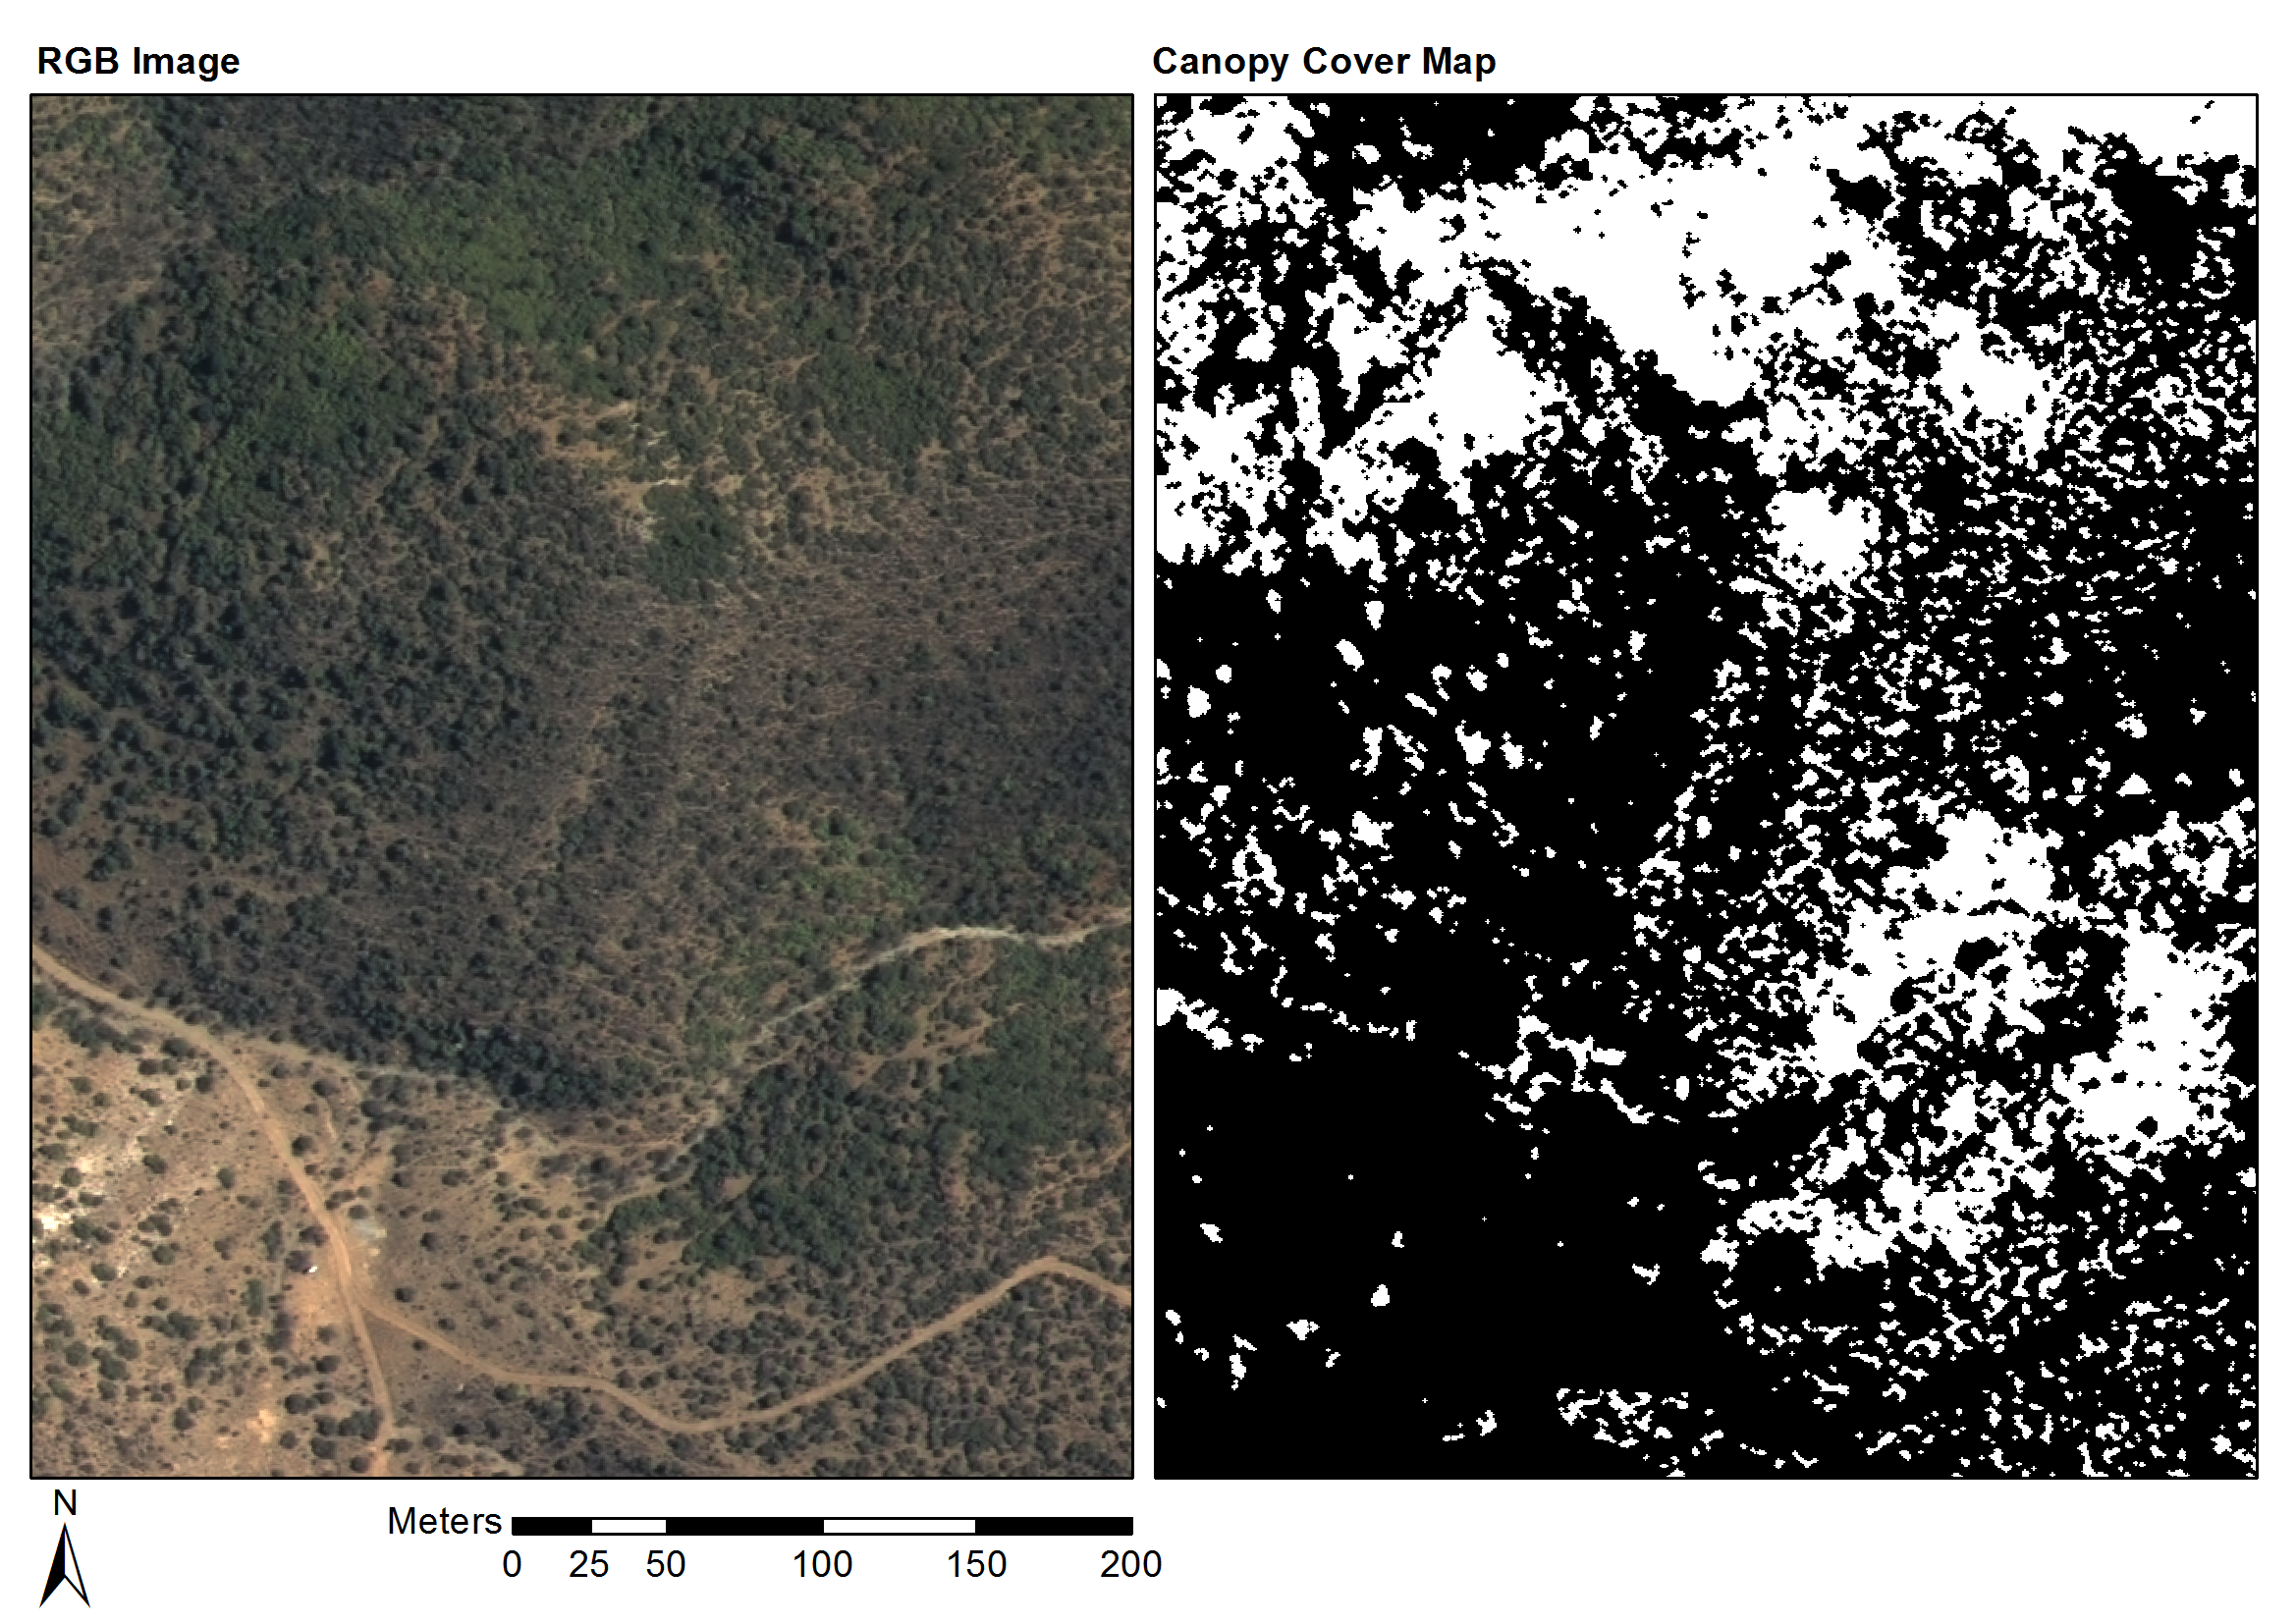

Figure 4.6 Groenfontein classification (Habitat: valley thicket with Spekboom)

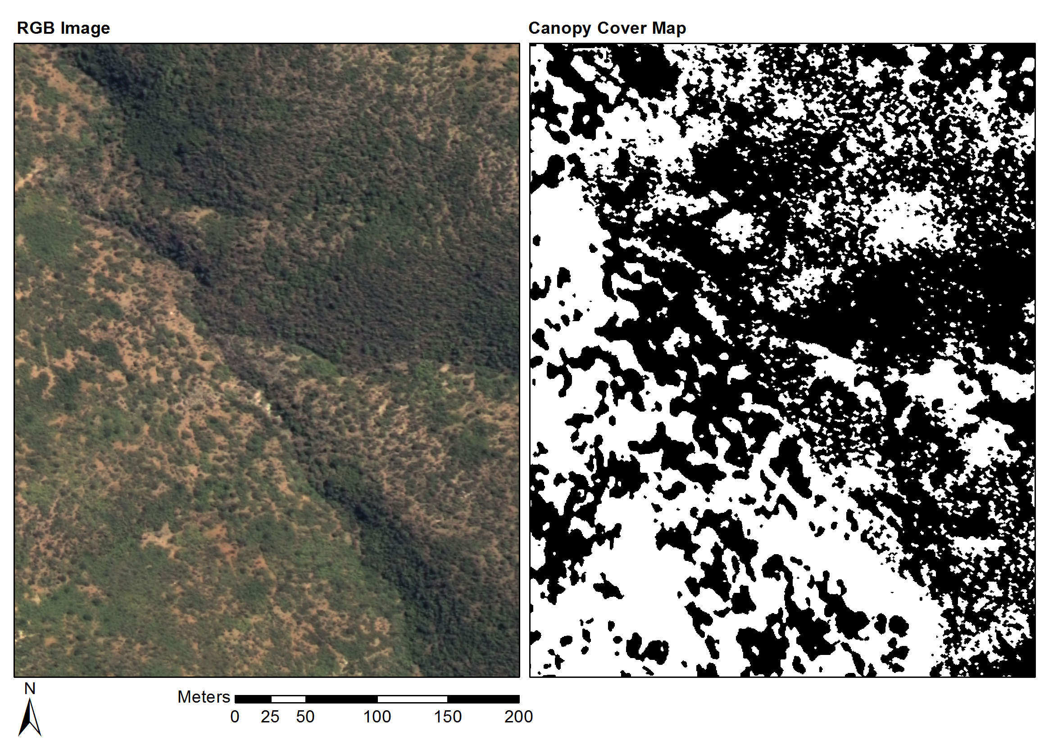

Figure 4.7 Matjiesvlei classification (Habitat: arid thicket with Spekboom)

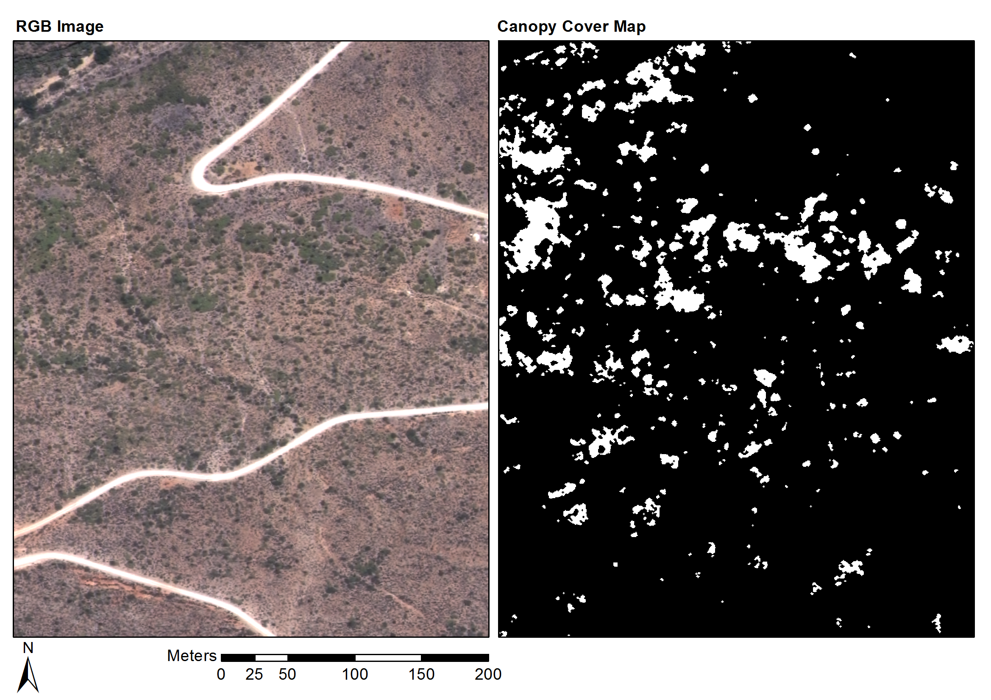

Figure 4.8 Rooiberg classification (Habitat: arid thicket with Spekboom and Fynbos mosaic)

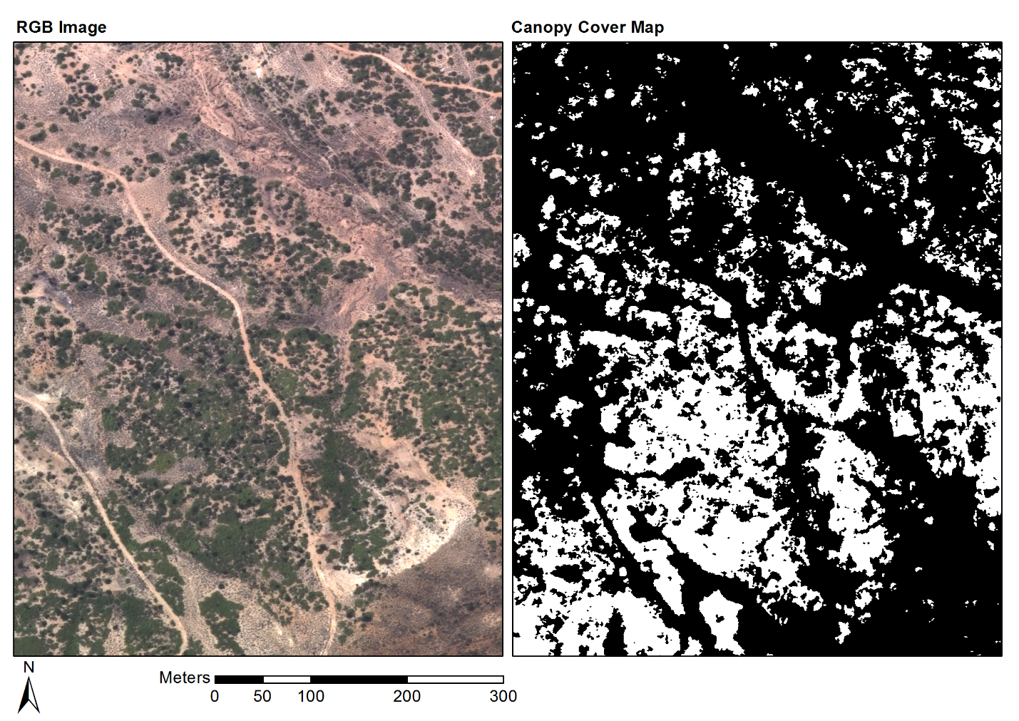

Figure 4.9 Grootkop classification (Habitat: arid thicket with Spekboom and Succulent Karoo mosaic)

## CONCLUSIONS

The per-pixel classification approach to *P. afra* canopy cover mapping was successful and good accuracies were achieved across the study area. Use of the mosaic cross calibration technique described in Chapter 2 was key in obtaining the radiometric consistency required to allow application of a single classification algorithm over an extended area. Six features, consisting of a combination of spectral, textural and vegetation index type measures, were selected with the feature clustering and ranking method described in Chapter 2. The feature set produced similarly good accuracies amongst a diverse set of candidate classifiers, confirming the feature selection method’s utility for finding informative features in the presence of correlation. A decision tree classifier was selected from the candidate classifiers due to its speed and accuracy on the field ground truth. Attention to the computational efficiency of feature extraction and classification methods assisted in being able to effectively experiment and process large volumes of images. The classifier produced a mean absolute canopy cover error of 5.86% and standard deviation of 4.85% over the 20 field ground truth sites.

While some variation in the classification accuracy was observed with habitat, the classifier was remarkably robust to the many sources of variation that make this a challenging problem. To the best of our knowledge, this is the first use of a mosaic of NGI aerial imagery in a quantitative remote sensing study. It is also one of very few examples of vegetation mapping using VHR imagery over a large area (Eisfelder, Kuenzer & Dech 2012; Lu 2006). The availability of a vegetation map covering the study area (Vlok, Cowling & Wolf 2005) and the assistance of an expert botanist in selecting and ground truthing the field sites were important contributors to the success of this study.

The map as it stands will provide a useful aid in selecting restoration sites and in choosing appropriate planting densities in the study area. By incorporating ground truth from new areas, the techniques used to produce this map can be extended to the rest of the thicket biome in the Little Karoo and Eastern Cape, where restoration work is also under way (Mills et al. 2010). Use of classifier developed here in combination with the Chapter 2 technique for calibration to a physical property of the surface, i.e. surface reflectance, enables repeated canopy cover monitoring of restoration sites over time. The availability of a *P. afra* canopy cover map will also be a valuable starting point for developing measures of other environmental variables such as biomass and biodiversity (Eisfelder, Kuenzer & Dech 2012; Suganuma et al. 2006; Ludwig, Reynolds & Whitson 1975).

While the mapping accuracies achieved compare well with related studies (Ghosh & Joshi 2014; Heumann 2011; Baraldi et al. 2010; Johansen et al. 2007; Mehner et al. 2004), there are many opportunities for improvement. Ancillary information such as slope aspect or habitat could be incorporated into the classifier, similarly to Thompson et al. (2009). This could be done by including it either as a feature or by designing separate classifiers for different ranges or categories of the ancillary variable. While spatial context was included in our classifier through the sliding window features and morphological post processing, texture information could be better exploited by following an object based approach (Blaschke 2010). Homogenous objects would allow the use of more descriptive texture features such as LBP’s and statistics of the GLCM. It was found that classifier performances on the image and field ground truth were not well correlated. This implied the image ground truth was not adequately representative of actual field variation. To obtain accurate pixel level ground truth it would be necessary to undertake a more precise field ground truthing exercise as it is not possible to label vegetation from visual inspection of the images with absolute certainty. Individual trees and *P. afra* clumps would have to be delineated across a range of habitats. Possible spatial inaccuracies between DGPS recorded polygons and the NGI orthrectified imagery could be adjusted by hand using the image as a visual reference.

REFERENCES

Adie H & Yeaton RI 2013. Regeneration dynamics in arid subtropical thicket, South Africa. *South African Journal of Botany* 88: 80–85.

Airbus Defence and Space 2014. Resolution and Spectral Bands [online]. Available from: http://www.astrium-geo.com/en/194-resolution-and-spectral-bands [Accessed June 14 2014].

Amorós López J, Izquierdo Verdiguier E, Gómez Chova L, Muñoz Marí J, Rodríguez Barreiro JZ, Camps Valls G & Calpe Maravilla J 2011. Land cover classification of VHR airborne images for citrus grove identification. *ISPRS Journal of Photogrammetry and Remote Sensing* 66 (1): 115–123.

Baldridge AM, Hook SJ, Grove CI & Rivera G 2009. The ASTER spectral library version 2.0. *Remote Sensing of Environment* 113 (4): 711–715.

Baraldi A, Durieux L, Simonetti D, Conchedda G, Holecz F & Blonda P 2010. Automatic spectral-rule-based preliminary classification of radiometrically calibrated SPOT-4/-5/IRS, AVHRR/MSG, AATSR, IKONOS/QuickBird/OrbView/GeoEye, and DMC/SPOT-1/-2 imagery—Part I: System design and implementation. *IEEE Transactions on Geoscience and Remote Sensing* 48 (3): 1299–1325.

Berk A, Anderson GP, Bernstein LS, Acharya PK, Dothe H, Matthew MW, Adler-Golden SM, Chetwynd JH, Richtsmeier SC, Pukall B, Allred CL, Jeong LS & Hoke ML 1999. MODTRAN4 radiative transfer modeling for atmospheric correction. In *Proceedings of SPIE - The International Society for Optical Engineering*, 348–353. Denver, CO: Society of Photo-Optical Instrumentation Engineers.

Bishop CM 2003. *Neural networks for pattern recognition*. New York: Oxford University Press.

Blaschke T 2010. Object based image analysis for remote sensing. *ISPRS Journal of Photogrammetry and Remote Sensing* 65 (1): 2–16.

Blauensteiner P, Wildenauer H, Hanbury A & Kampel M 2006. On colour spaces for change detection and shadow suppression. In O. Chum & V. Franc (eds) *Computer Vision Winter Workshop 2006*, 1–6. Telc, Czech Republic: Czech Pattern Recognition Society.

Bradski G 2000. The OpenCV library. *Dr. Dobb’s Journal of Software Tools* 25 (120): 122– 125.

Breiman L 1996. Bagging predictors. *Machine Learning* 24 (2): 123–140.

Breiman L 2001. Random Forests. *Machine Learning* 45 (1): 5–32.

Breiman L, Friedman J, Olshen R & Stone C 1984. *Classification and regression trees*. Calif.: Wadsworth.

Burges CJC 1998. A tutorial on support vector machines for pattern recognition. *Data Mining and Knowledge Discovery* 2 (2): 121–167.

Carleer AP, Debeir O & Wolff E 2005. Assessment of very high spatial resolution satellite image segmentations. *Photogrammetric Engineering & Remote Sensing* 71 (11): 1285–1294.

Chandelier L & Martinoty G 2009. A radiometric aerial triangulation for the equalization of digital aerial images and orthoimages. *Photogrammetric Engineering & Remote Sensing* 75 (2): 193–200.

Chander G, Meyer DJ & Helder DL 2004. Cross calibration of the Landsat-7 ETM+ and EO-1 ALI sensor. *IEEE Transactions on Geoscience and Remote Sensing* 42 (12): 2821–2831.

Collings S, Caccetta P, Campbell N & Wu X 2011. Empirical models for radiometric calibration of digital aerial frame mosaics. *IEEE Transactions on Geoscience and Remote Sensing* 49 (7): 2573–2588.

Cover TM 1974. The best two independent measurements are not the two best. *IEEE Transactions on Systems, Man, and Cybernetics* SMC-4 (1): 116–117.

Curran P, Smedley D, Thompson P & Knight AT 2012. Mapping restoration opportunity for collaborating with land managers in a carbon credit-funded restoration program in the Makana municipality, Eastern Cape, South Africa. *Restoration Ecology* 20 (1): 56–64.

Downey M, Uebbing R, Gehrke S & Beisl U 2010. Radiometric processing of ADS imagery: using atmospheric and brdf corrections in production. In *ASPRS 2010 Annual Conference*. San Diego, CA, USA.

Duin RPW & Tax DMJ 2005. Statistical Pattern Recognition. In C. Chen & P. Wang (eds) *Handbook of Pattern Recognition and Computer Vision, 3rd ed.*, 1–21. Singapore: World Scientific.

Eisfelder C, Kuenzer C & Dech S 2012. Derivation of biomass information for semi-arid areas using remote-sensing data. *International Journal of Remote Sensing* 33 (9): 2937–2984.

Fabricius C, Burger M & Hockey PAR 2003. Comparing biodiversity between protected areas and adjacent rangeland in xeric succulent thicket, South Africa: arthropods and reptiles. *Journal of Applied Ecology* 40 (2): 392–403.

Food and Agriculture Organization (FAO) 1989. Arid zone forestry: a guide for field technicians. [online]. Available from: http://www.fao.org/docrep/T0122E/t0122e03.htm [Accessed May 22 2012].

Forsyth G, Vlok J & Reyers B 2008. *Retention and restoration of the biodiversity of the Little Karoo*. CSIR Report No CSIR/NRE/ECO/ER/2008/0118/C. CSIR.

Gao C, Jiang X, Li X & Li X 2013. The cross-calibration of CBERS-02B/CCD visible-near infrared channels with Terra/MODIS channels. *International Journal of Remote Sensing* 34 (9-10): 3688–3698.

Gates DM 1980. *Biophysical Ecology*. New York: Springer.

GDAL Development Team 2014. Geospatial Data Abstraction Library [online]. Open Source Geospatial Foundation. Available from: http://www.gdal.org/.

Gehrke S 2010. Radiometric processing of ADS imagery: mosaicking of large image blocks. In *Opportunities for Emerging Geospatial Technologies*, 184–195. American Society for Photogrammetry and Remote Sensing Annual Conference 2010 held 26-30 April 2010. San Diego, United States: American Society for Photogrammetry and Remote Sensing.

Ghosh A & Joshi PK 2014. A comparison of selected classification algorithms for mapping bamboo patches in lower Gangetic plains using very high resolution WorldView 2 imagery. *International Journal of Applied Earth Observation and Geoinformation* 26: 298–311.

Guralnick LJ & Ting IP 1986. Seasonal response to drought and rewatering in Portulacaria afra (L.) Jacq. *Oecologia* 70: 85–91.

Hand DJ & Yu K 2001. Idiot’s Bayes - not so stupid after all? *International Statisitical Review* 69 (3): 385–398.

Hein L, de Ridder N, Hiernaux P, Leemans R, de Wit A & Schaepman M 2011. Desertification in the Sahel: Towards better accounting for ecosystem dynamics in the interpretation of remote sensing images. *Journal of Arid Environments* 75 (11): 1164–1172.

Heumann BW 2011. Satellite remote sensing of mangrove forests: Recent advances and future opportunities. *Progress in Physical Geography* 35 (1): 87–108.

Honkavaara E, Arbiol R, Markelin L, Martinez L, Cramer M, Bovet S, Chandelier L, Ilves R, Klonus S, Marshal P, Schläpfer D, Tabor M, Thom C & Veje N 2009. Digital airborne photogrammetry—a new tool for quantitative remote sensing?—A state-of-the-art review on radiometric aspects of digital photogrammetric images. In *Remote Sensing*, 577–605.

Intergraph 2008. Digital mapping camera system [online]. Available from: http://www.geospace.co.za/pdf/DMC Brochure.pdf.

Jain AK, Duin RPW & Mao J 2000. Statistical pattern recognition: a review. *IEEE Transactions on Pattern Analysis and Machine Intelligence* 22 (1): 4–37.

Jiang GM & Li ZL 2009. Cross-calibration of MSG1-SEVIRI infrared channels with Terra-MODIS channels. *International Journal of Remote Sensing* 30 (3): 753–769.

Johansen K, Coops NC, Gergel SE & Stange Y 2007. Application of high spatial resolution satellite imagery for riparian and forest ecosystem classification. *Remote Sensing of Environment* 110 (1): 29–44.

Kauth RJ & Thomas GS 1976. The tasselled cap -- a graphic description of the spectral-temporal development of agricultural crops as seen by LANDSAT. In *Symposium on Machine Processing of Remotely Sensed Data*, 4B41–4B51. Purdue University of West Lafayette, Indiana, USA: IEEE.

Knight AT, Cowling RM, Boshoff AF, Wilson SL & Pierce S 2011. Walking in STEP: Lessons for linking spatial prioritisations to implementation strategies. *Biological Conservation* 144 (1): 202–211.

Lechmere-Oertel RG, Kerley G, Mills AJ & Cowling RM 2008. Litter dynamics across browsing-induced fenceline contrasts in succulent thicket, South Africa. *South African Journal of Botany* 74 (4): 651–659.

Lelong CCD, Burger P, Jubelin G, Roux B, Labbé S & Baret F 2008. Assessment of unmanned aerial vehicles imagery for quantitative monitoring of wheat crop in small plots. *Sensors* 8 (5): 3557–3585.

Lévesque J & King DJ 2003. Spatial analysis of radiometric fractions from high-resolution multispectral imagery for modelling individual tree crown and forest canopy structure and health. *Remote Sensing of Environment* 84 (4): 589–602.

Li L, Yang J & Wang Y 2012. Cross-calibration of HJ-1B/CCD1 image based on Aqua/MODIS data. In *2012 Second International Workshop on Earth Observation and Remote Sensing Applications*, 116–119. Shanghai, China: IEEE.

Li Z, Hayward RF, Zhang J, Jin H & Walker RA 2010. Evaluation of spectral and texture features for object-based vegetation species classification using support vector machines. In W. Wagner & B. Székely (eds) *ISPRS TC VII Symposium – 100 Years ISPRS*, 122–127. Vienna, Austria: IAPRS.

Liu J-J, Li Z, Qiao Y-L, Liu Y-J & Zhang Y-X 2004. A new method for cross-calibration of two satellite sensors. *International Journal of Remote Sensing* 25 (23): 5267–5281.

López DH, García BF, Piqueras JG & Guillermo VA 2011. An approach to the radiometric aerotriangulation of photogrammetric images. *ISPRS Journal of Photogrammetry and Remote Sensing* 66 (6): 883–893.

Lu D 2006. The potential and challenge of remote sensing based biomass estimation. *International Journal of Remote Sensing* 27 (7): 1297–1328.

Ludwig JA, Reynolds JF & Whitson PD 1975. Size-biomass relationships of several Chihuahuan desert shrubs. *American Midland Naturalist* 94 (2): 451–461.

van Luijk G, Cowling RM, Riksen MJPM & Glenday J 2013. Hydrological implications of desertification: Degradation of South African semi-arid subtropical thicket. *Journal of Arid Environments* 91: 14–21.

Manabe S & Strickler RF 1964. Thermal equilibrium of the atmosphere with a convective adjustment. *Journal of the Atmospheric Sciences* 21 (4): 361–385.

Marais C, Cowling RM & Powell M 2009. Establishing the platform for a carbon sequestration market in South Africa: The Working for Woodlands Subtropical Thicket Restoration Programme. In *XIII World Forestry Congress*, 1–13. Buenos Aires, Argentina.

Markelin L, Honkavaara E, Schläpfer D, Bovet S & Korpela I 2012. Assessment of radiometric correction methods for ADS40 imagery. *Photogrammetrie - Fernerkundung - Geoinformation* 2012 (3): 251–266.

Mehner H, Cutler M, Fairbairn D & Thompson G 2004. Remote sensing of upland vegetation: the potential of high spatial resolution satellite sensors. *Global Ecology and Biogeography* 13 (4): 359–369.

Mills AJ, Blignaut J, Cowling RM, Knipe A, Marais C, Marais S, Pierce S, Powell M, Sigwela A & Skowno A 2010. *Investing in sustainability. Restoring degraded thicket, creating jobs, capturing carbon and earning green credit.* Climate Action Partnership, Cape Town and Wilderness Foundation, Port Elizabeth.

Mills AJ & Cowling RM 2010. Below-ground carbon stocks in intact and transformed subtropical thicket landscapes in semi-arid South Africa. *Journal of Arid Environments* 74 (1): 93–100.

Mills AJ & Cowling RM 2006. Rate of carbon sequestration at two thicket restoration sites in the Eastern Cape, South Africa. *Restoration Ecology* 14 (1): 38–49.

Mills AJ, Cowling RM, Fey M, Kerley G, Donaldson J, Sigwela A, Skowno A & Rundel P 2005. Effects of goat pastoralism on ecosystem carbon storage in semiarid thicket, Eastern Cape, South Africa. *Austral Ecology* 30: 797–804.

Mills AJ & Fey M 2004. Transformation of thicket to savanna reduces soil quality in the Eastern Cape, South Africa. *Plant and Soil* 265 (1-2): 153–163.

Mills AJ, Turpie JK, Cowling RM, Marais C, Kerley G, Richard G, Sigwela A & Powell M 2007. Assessing costs, benefits, and feasibility of restoring natural capital in Subtropical Thicket in South Africa. In J. Aronson, S. Milton, & J. Blignaut (eds) *Restoring Natural Capital: Science, Business and Practice (The Science and Practice of Ecological Restoration Series)*, 179–187. Washington DC: Island Press.

Mingguo Z, Qianguo C & Mingzhou Q 2009. The Effect of Prior Probabilities in the Maximum Likelihood Classification on Individual Classes. *Photogrammetric Engineering & Remote Sensing* 75 (9): 1109–1117.

MODIS Land Team 2014. EOS validation status for MODIS BRDF/albedo: MCD43 [online]. Available from: http://landval.gsfc.nasa.gov/ProductStatus.php?ProductID=MOD43 [Accessed June 6 2014].

Mouton J 2001. *How to succeed in your master’s and doctoral studies : a South African guide and resource book*. Pretoria: Van Schaik Publishers.

Myneni RB, Hall FG, Sellers PJ & Marshak AL 1995. The interpretation of spectral vegetation indexes. *IEEE Transactions on Geoscience and Remote Sensing* 33 (2): 481–486.

NASA 2014. Components of MODIS [online]. Available from: http://modis.gsfc.nasa.gov/about/specifications.php [Accessed June 14 2014].

National Geo-spatial Information 2012. National aerial photography and imagery programme [online]. Department of Rural Development and Land Reform (DRDLR). Available from: http://www.ngi.gov.za/index.php/Image-tabs-home/national-aerial-photography-and-imagery-programme.html [Accessed May 22 2012].

OpenCV Development Team 2014. OpenCV documentation [online]. Open Source Computer Vision Library. Available from: http://docs.opencv.org/.

Pierce S, Cowling RM, Knight AT, Lombard AT, Rouget M & Wolf T 2005. Systematic conservation planning products for land-use planning: Interpretation for implementation. *Biological Conservation* 125 (4): 441–458.

Pohl C & Van Genderen JL 1998. Multisensor image fusion in remote sensing: Concepts, methods and applications. *International Journal of Remote Sensing* 19 (5): 823–854.

Restoration Research Group 2012. Intact and degraded Spekboomveld [online]. Available from: http://www.r3g.co.za/spekboom.htm.

Richter R 1997. Correction of atmospheric and topographic effects for high spatial resolution satellite imagery. *International Journal of Remote Sensing* 18 (5): 1099–1111.

Roujean J-L, Leroy M & Deschamps P-Y 1992. A bidirectional reflectance model of the Earth’s surface for the correction of remote sensing data. *Journal of Geophysical Research* 97 (D18): 20455.

Sahu B & Mishra D 2011. A novel approach for selecting informative genes from gene expression data using signal-to-noise ratio and t-statistics. In *2011 2nd International Conference on Computer and Communication Technology (ICCCT-2011)*, 5–10. Allahabad, India: IEEE.

Schaepman-Strub G, Schaepman ME, Painter TH, Dangel S & Martonchik JV 2006. Reflectance quantities in optical remote sensing—definitions and case studies. *Remote Sensing of Environment* 103 (1): 27–42.

Serra J & Soille P (eds). 1994. Mathematical morphology and its applications to image processing. In *2nd International Symposium on Mathematical Morphology (ISMM’94)*, 383. Computational imaging and vision. Kluwer Academic Publishers.

Sigwela A, Kerley G, Mills AJ & Cowling RM 2009. The impact of browsing-induced degradation on the reproduction of subtropical thicket canopy shrubs and trees. *South African Journal of Botany* 75 (2): 262–267.

Singh M, Malhi Y & Bhagwat S 2014. Biomass estimation of mixed forest landscape using a Fourier transform texture-based approach on very-high-resolution optical satellite imagery. *International Journal of Remote Sensing* 35 (9): 3331–3349.

Statistics South Africa 2011. *Quarterly labour force survey quarter 1, 2011*. P0211. Pretoria: Statistics South Africa.

Strahler AH, Wanner W, Lucht W, Schaaf CB, Tsang T, Gao F, Li X, Muller J-P, Lewis P & Barnsley MJ 1999. MODIS BRDF/albedo product: algorithm theoretical basis document version 5.0 [online]. Available from: http://modis.gsfc.nasa.gov/data/atbd/atbd_mod09.pdf [Accessed May 27 2014].

Strobl C, Boulesteix A-L, Kneib T, Augustin T & Zeileis A 2008. Conditional variable importance for random forests. *BMC bioinformatics* 9: 307.

Stuart-Hill G 1992. Effects of elephants and goats on the Kaffrarian succulent thicket of the eastern Cape, South Africa. *Journal of Applied Ecology* 29 (3): 699–710.

Suganuma H, Abe Y, Taniguchi M, Tanouchi H, Utsugi H, Kojima T & Yamada K 2006. Stand biomass estimation method by canopy coverage for application to remote sensing in an arid area of Western Australia. *Forest Ecology and Management* 222 (1-3): 75–87.

Szekely GJ & Rizzo ML 2005. Hierarchical clustering via joint between-within distances: extending Ward’s minimum variance method. *Journal of Classification* 22 (2): 151–183.

Teillet P., Barker J., Markham B., Irish R., Fedosejevs G & Storey J. 2001. Radiometric cross-calibration of the Landsat-7 ETM+ and Landsat-5 TM sensors based on tandem data sets. *Remote Sensing of Environment* 78 (1-2): 39–54.

Thompson M, Vlok J, Rouget M, Hoffman MT & Cowling RM 2009. Mapping grazing-induced degradation in a semi-arid environment: A rapid and cost effective approach for assessment and monitoring. *Environmental Management* 43: 585–596.

Thompson MW, Vlok J, Cowling RM, Cundill SL & Mudau N 2005. *A land transformation map of the Little Karoo*. Pretoria: GeoterraImage.

Tolosi L & Lengauer T 2011. Classification with correlated features: unreliability of feature ranking and solutions. *Bioinformatics* 27 (14): 1986–1994.

Trias-Sanz R, Stamon G & Louchet J 2008. Using colour, texture, and hierarchial segmentation for high-resolution remote sensing. *ISPRS Journal of Photogrammetry and Remote Sensing* 63 (2): 156–168.

Turner MD 2003. Methodological reflections on the use of remote sensing and geographic information science in human ecological research. *Human Ecology* 31 (2): 255–279.

Vermote EF, Tanre D, Deuze JL, Herman M & Morcette J-J 1997. Second simulation of the satellite signal in the solar spectrum, 6S: an overview. *IEEE Transactions on Geoscience and Remote Sensing* 35 (3): 675–686.

Verstraete MM, Hunt LA, Scholes RJ, Clerici M, Pinty B & Nelson DL 2012. Generating 275-m Resolution Land Surface Products From the Multi-Angle Imaging SpectroRadiometer Data. *IEEE Transactions on Geoscience and Remote Sensing* 50 (10): 3980–3990.

Vicente-Serrano S, Pérez-Cabello F & Lasanta T 2008. Assessment of radiometric correction techniques in analyzing vegetation variability and change using time series of Landsat images. *Remote Sensing of Environment* 112 (10): 3916–3934.

Vlok J, Cowling RM & Wolf T 2005. A vegetation map for the Little Karoo. Unpublished maps and report for a SKEP project supported by CEPF grant no 1064410304.

Vyver ML, Cowling RM, Campbell EE & Difford M 2012. Active restoration of woody canopy dominants in degraded South African semi-arid thicket is neither ecologically nor economically feasible. *Applied Vegetation Science* 15 (1): 26–34.

van der Vyver ML, Cowling RM, Mills AJ & Difford M 2013. Spontaneous return of biodiversity in restored subtropical thicket: Portulacaria afra as an ecosystem engineer. *Restoration Ecology* 21 (6): 736–744.

Wulder MA, Hall RJ, Coops NC, Steven E & Franklin SE 2004. High spatial resolution remotely sensed data for ecosystem characterization. *BioScience* 54 (6): 511–521.

Xu M, Watanachaturaporn P, Varshney P & Arora M 2005. Decision tree regression for soft classification of remote sensing data. *Remote Sensing of Environment* 97 (3): 322–336.

Yousef M, Jung S, Showe LC & Showe MK 2007. Recursive cluster elimination (RCE) for classification and feature selection from gene expression data. *BMC Bioinformatics* 8 (144).

Yu L & Liu H 2004. Efficient feature selection via analysis of relevance and redundancy. *Journal of Machine Learning Research* 5 (2004): 1205–1224.

Yu Q, Gong P, Clinton N, Biging G, Kelly M & Schirokauer D 2006. Object-based detailed vegetation classification with airborne high spatial resolution remote sensing imagery. *Photogrammetric Engineering & Remote Sensing* 72 (7): 799–811.

**PERSONAL COMMUNICATIONS**

List your personal communications here.

See the departmental guidelines for instructions.

**APPENDICES**

|  |  |  |
| --- | --- | --- |
| Appendix A | Title of first appendix | 8 |
| Appendix B | Title of second appendix | 9 |

**APPENDIX A**

Title of fist appendix

Appendix content

**APPENDIX B**

Title of second appendix

Content

Note: These references were automatically inserted here (at the end of the document) by EndNote and must be manually copied to the reference list. Alternatively, one can put the appendixes in a separate document so that the reference list is at the very end of the document. This will automatically update your reference list as you work on the document.

Saaty TL & Vargas LG 1991. *Prediction, projection and forcasting.* Boston: Kluwer Academic Publishers.

Turner D 2005. Transkei and ciskei land type survey [online]. ARC. Available from <http://www.arc-iscw.agric.za/main/projects/landtype.htm> [Accessed 23-06-2005].